**University of Engineering and Technology,Taxila**

**Department of Computer Engineering**

# Assignment

**For the Course of DSD**

**Submitted By**:Muhammad Ibrahim (21-CP-26)

**Section:** Omega

## **Lab Instructor:**Sir Shahid Ali

**Course Instructor:**Dr.Abdul rehman aslam

**Date**: 05-02-24.

## **Course Title**: DSD

**Questions/Answer**

**1. Design the following basic gates using 2-to-1 multiplexers only. (40 Marks)**

**a. Inverter**

**Truth table:**

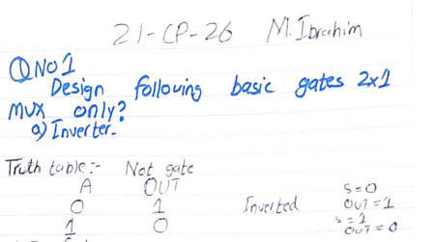

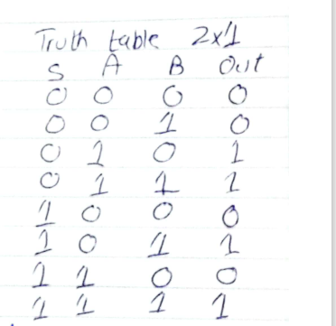

**Circuit diagram :**

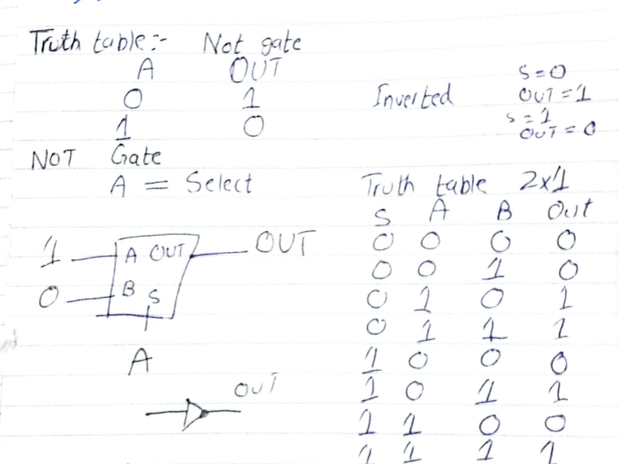

**Code:**

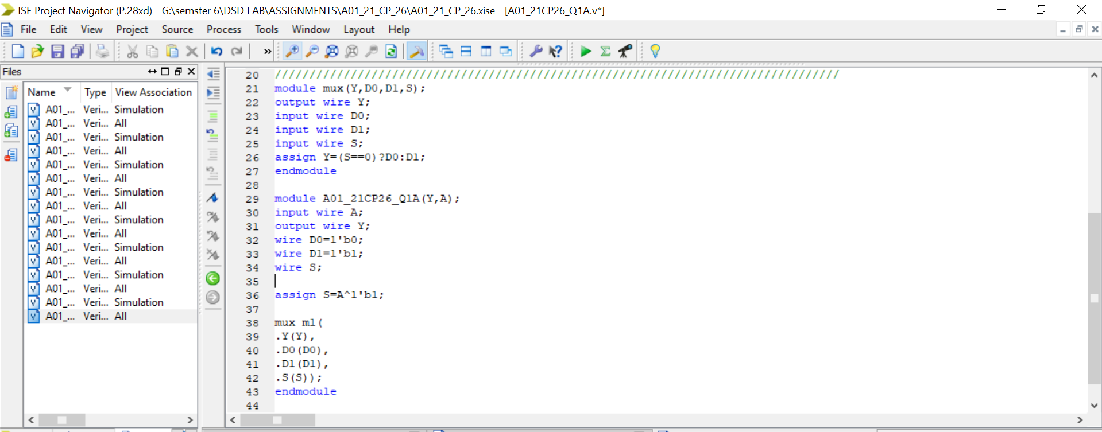

`timescale 1ns / 1ps

//////////////////////////////////////////////////////////////////////////////////

// Company:

// Engineer:

//

// Create Date: 13:43:56 01/27/2024

// Design Name:

// Module Name: A01_21CP26_Q1A

// Project Name:

// Target Devices:

// Tool versions:

// Description:

//

// Dependencies:

//

// Revision:

// Revision 0.01 - File Created

// Additional Comments:

//

//////////////////////////////////////////////////////////////////////////////////

module mux(Y,D0,D1,S);

output wire Y;

input wire D0;

input wire D1;

input wire S;

assign Y=(S==0)?D0:D1;

endmodule

module A01_21CP26_Q1A(Y,A);

input wire A;

output wire Y;

wire D0=1'b0;

wire D1=1'b1;

wire S;

assign S=A^1'b1;

mux m1(

.Y(Y),

.D0(D0),

.D1(D1),

.S(S));

endmodule

**TestBench:**

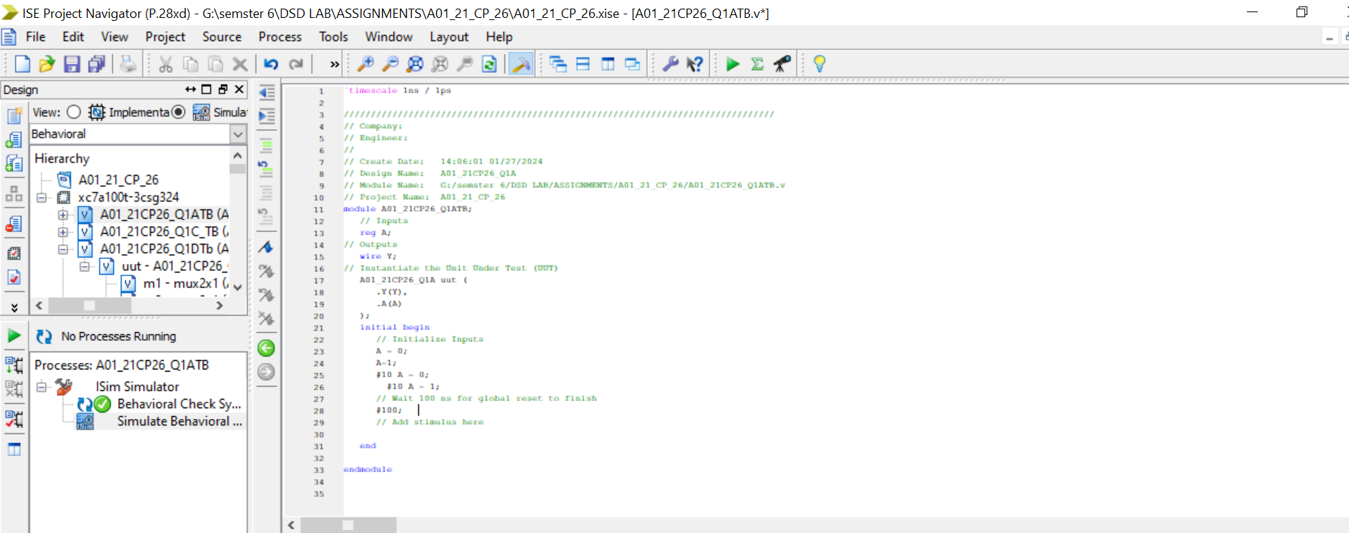

`timescale 1ns / 1ps

////////////////////////////////////////////////////////////////////////////////

// Company:

// Engineer:

//

// Create Date: 14:06:01 01/27/2024

// Design Name: A01_21CP26_Q1A

// Module Name: G:/semster 6/DSD LAB/ASSIGNMENTS/A01_21_CP_26/A01_21CP26_Q1ATB.v

// Project Name: A01_21_CP_26

module A01_21CP26_Q1ATB;

// Inputs

reg A;

// Outputs

wire Y;

// Instantiate the Unit Under Test (UUT)

A01_21CP26_Q1A uut (

.Y(Y),

.A(A)

);

initial begin

// Initialize Inputs

A = 0;

A=1;

#10 A = 0;

#10 A = 1;

// Wait 100 ns for global reset to finish

#100;

// Add stimulus here

end

endmodule

**Simulation:**

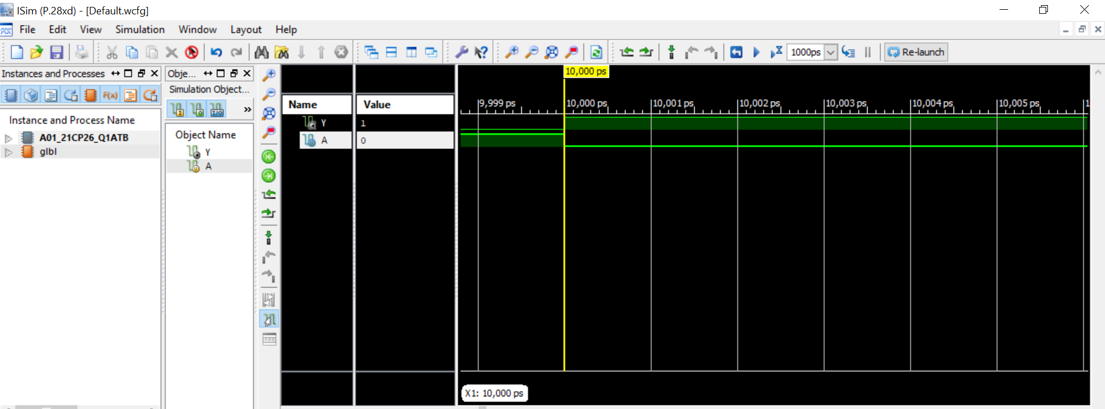

b. 2-input and gate

**Truth table:**

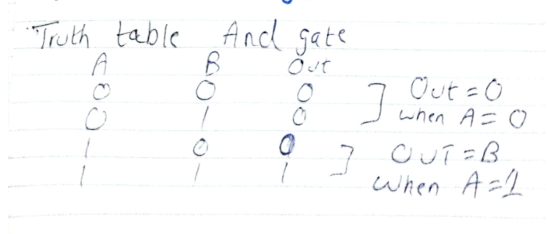

**Circuit diagram :**

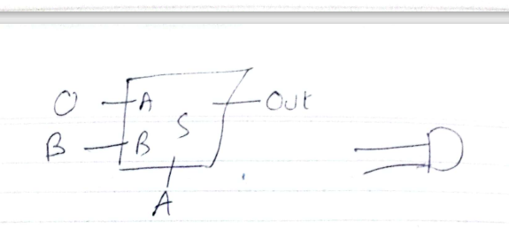

**Code:**

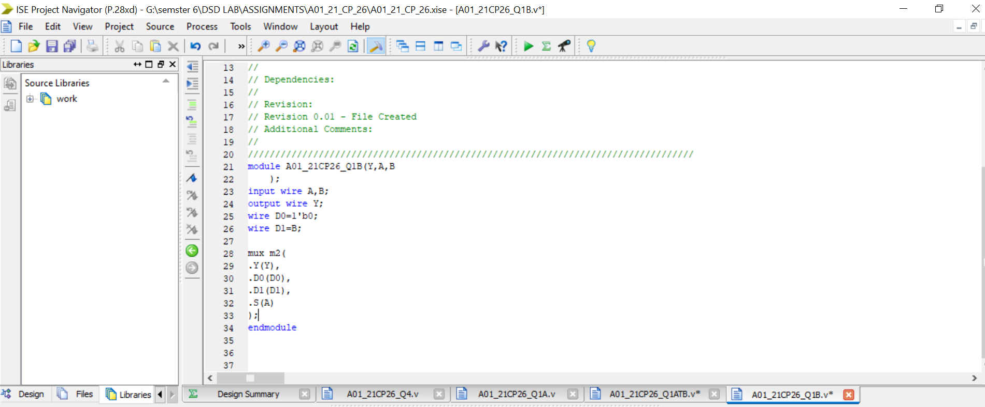

`timescale 1ns / 1ps

//////////////////////////////////////////////////////////////////////////////////

// Company:

// Engineer:

//

// Create Date: 14:22:04 01/27/2024

// Design Name:

// Module Name: A01_21CP26_Q1B

// Project Name:

// Target Devices:

// Tool versions:

// Description:

//

// Dependencies:

//

// Revision:

// Revision 0.01 - File Created

// Additional Comments:

//

//////////////////////////////////////////////////////////////////////////////////

module A01_21CP26_Q1B(Y,A,B

);

input wire A,B;

output wire Y;

wire D0=1'b0;

wire D1=B;

mux m2(

.Y(Y),

.D0(D0),

.D1(D1),

.S(A)

);

endmodule

**TestBench:**

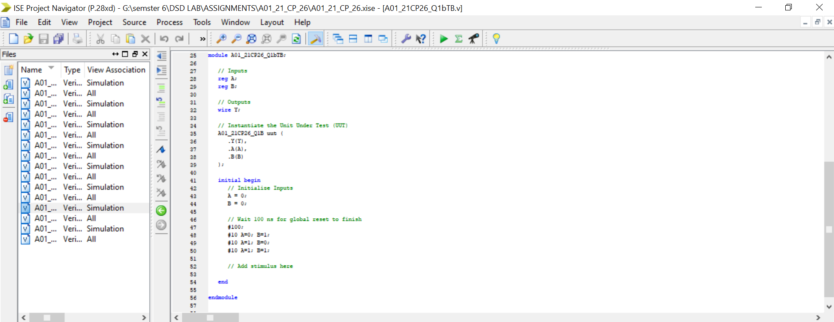

**`**timescale 1ns / 1ps

////////////////////////////////////////////////////////////////////////////////

// Company:

// Engineer:

//

// Create Date: 14:27:45 01/27/2024

// Design Name: A01_21CP26_Q1B

// Module Name: G:/semster 6/DSD LAB/ASSIGNMENTS/A01_21_CP_26/A01_21CP26_Q1bTB.v

// Project Name: A01_21_CP_26

// Target Device:

// Tool versions:

// Description:

//

// Verilog Test Fixture created by ISE for module: A01_21CP26_Q1B

//

// Dependencies:

//

// Revision:

// Revision 0.01 - File Created

// Additional Comments:

//

////////////////////////////////////////////////////////////////////////////////

module A01_21CP26_Q1bTB;

// Inputs

reg A;

reg B;

// Outputs

wire Y;

// Instantiate the Unit Under Test (UUT)

A01_21CP26_Q1B uut (

.Y(Y),

.A(A),

.B(B)

);

initial begin

// Initialize Inputs

A = 0;

B = 0;

// Wait 100 ns for global reset to finish

#100;

#10 A=0; B=1;

#10 A=1; B=0;

#10 A=1; B=1;

// Add stimulus here

end

endmodule

**Simulation:**

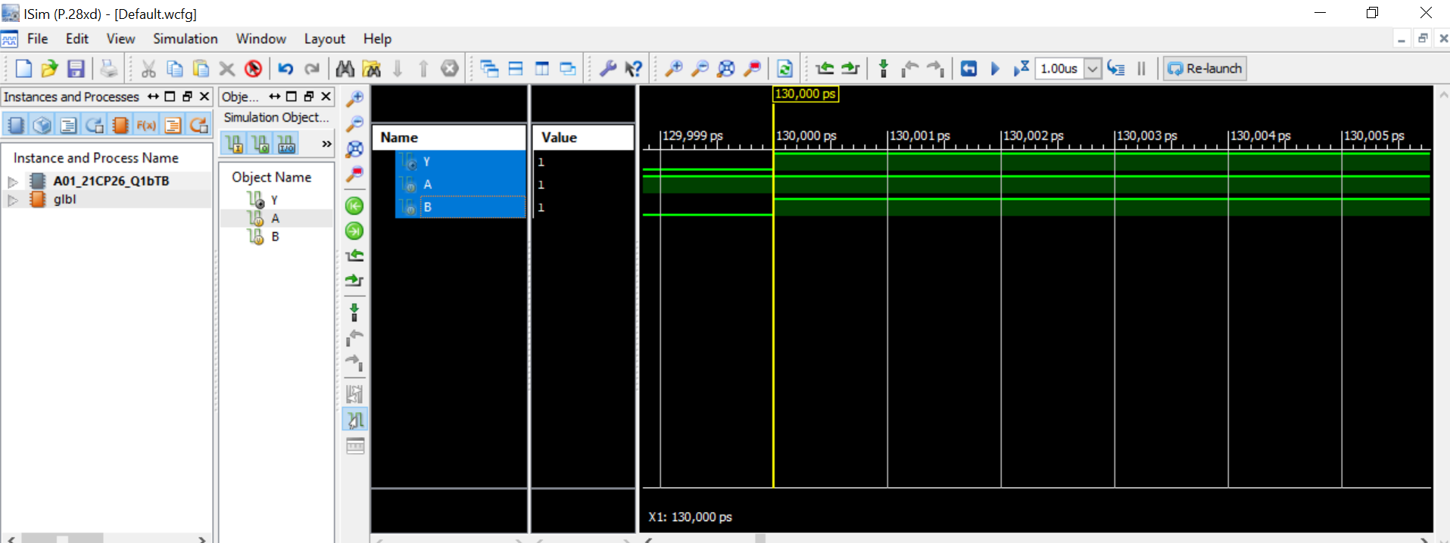

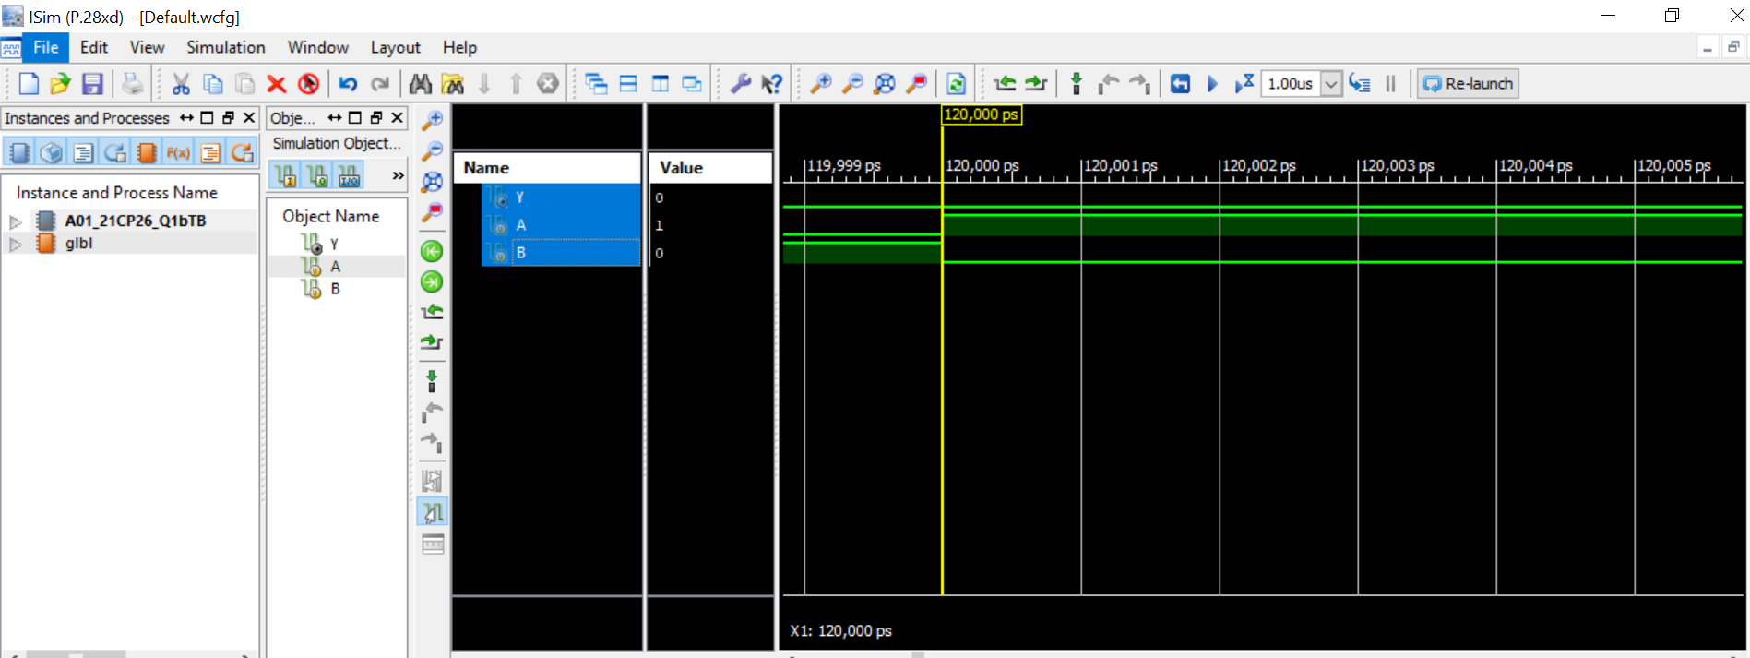

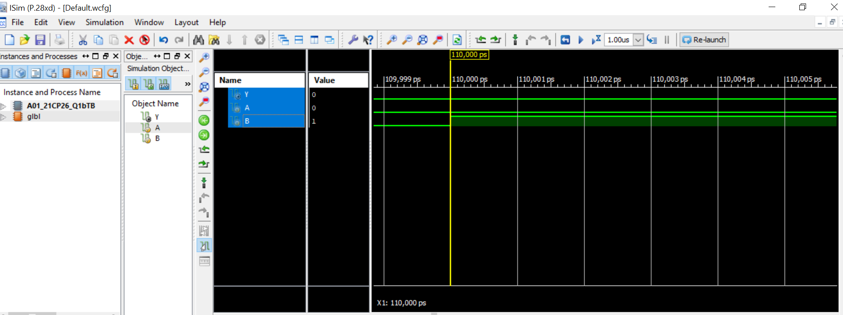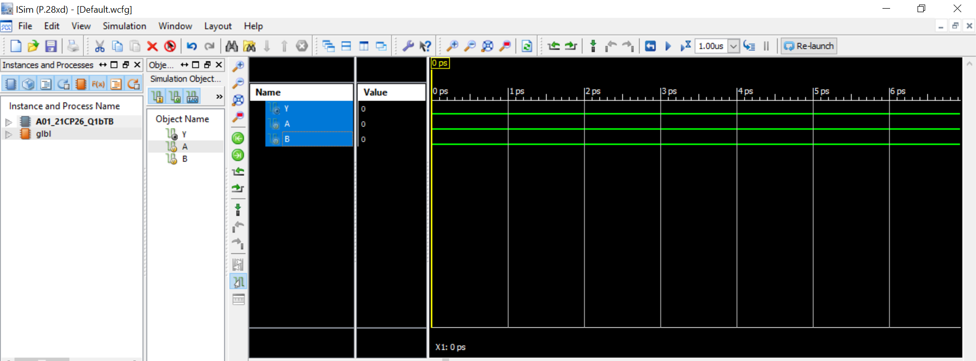

**c. 2-input or gate**

**Truth table:**

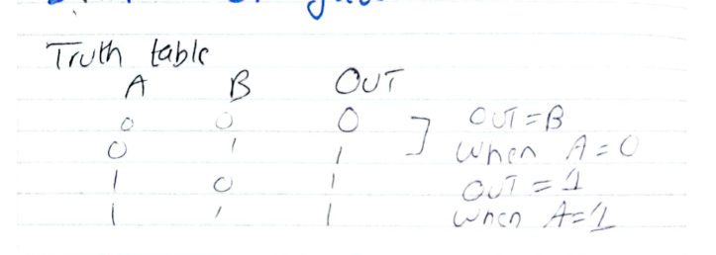

**Circuit diagram :**

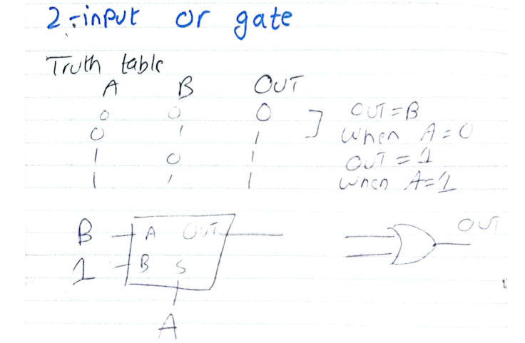

**Code:**

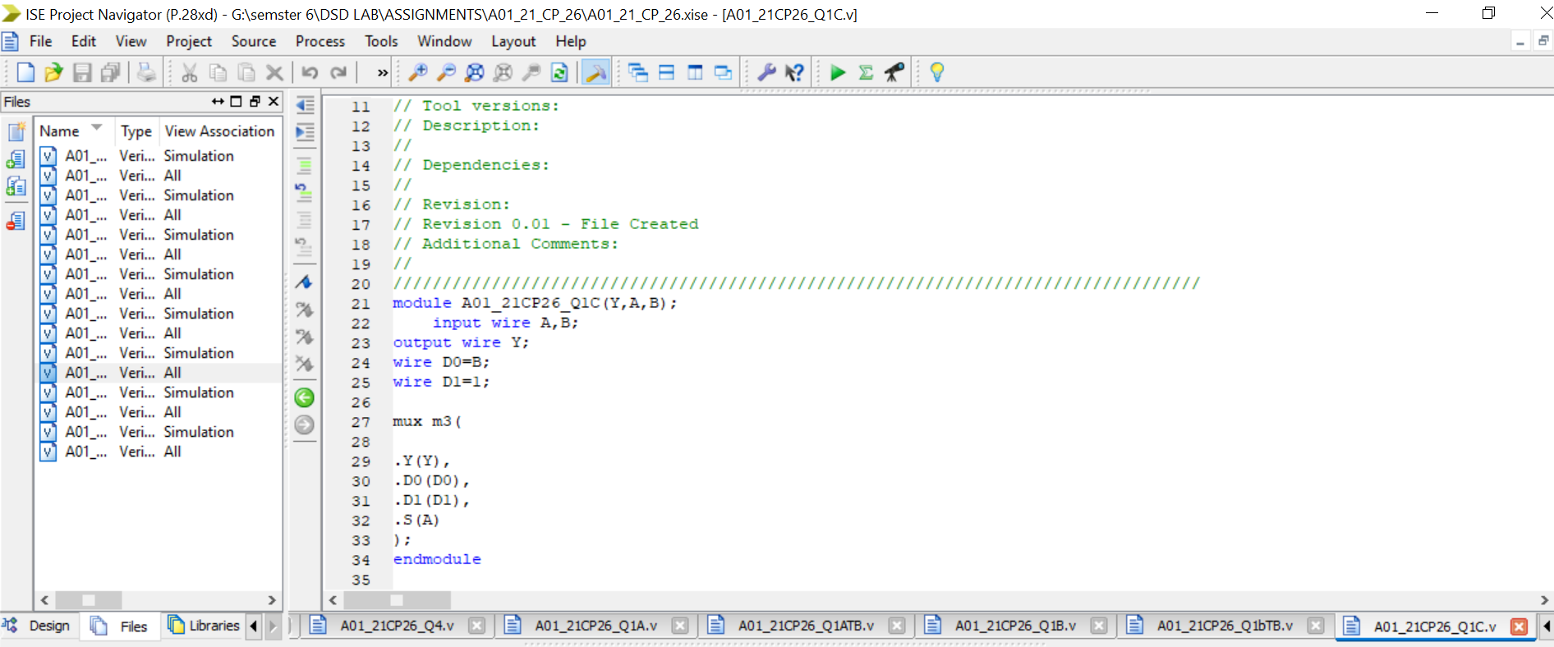

`timescale 1ns / 1ps

//////////////////////////////////////////////////////////////////////////////////

// Company:

// Engineer:

//

// Create Date: 14:33:45 01/27/2024

// Design Name:

// Module Name: A01_21CP26_Q1C

// Project Name:

// Target Devices:

// Tool versions:

// Description:

//

// Dependencies:

//

// Revision:

// Revision 0.01 - File Created

// Additional Comments:

//

//////////////////////////////////////////////////////////////////////////////////

module A01_21CP26_Q1C(Y,A,B);

input wire A,B;

output wire Y;

wire D0=B;

wire D1=1;

mux m3(

.Y(Y),

.D0(D0),

.D1(D1),

.S(A)

);

endmodule

**TestBench:**

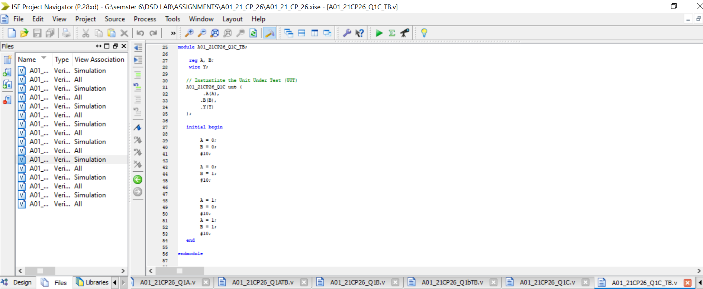

`timescale 1ns / 1ps

////////////////////////////////////////////////////////////////////////////////

// Company:

// Engineer:

//

// Create Date: 14:38:03 01/27/2024

// Design Name: A01_21CP26_Q1C

// Module Name: G:/semster 6/DSD LAB/ASSIGNMENTS/A01_21_CP_26/A01_21CP26_Q1C_TB.v

// Project Name: A01_21_CP_26

// Target Device:

// Tool versions:

// Description:

//

// Verilog Test Fixture created by ISE for module: A01_21CP26_Q1C

//

// Dependencies:

//

// Revision:

// Revision 0.01 - File Created

// Additional Comments:

//

////////////////////////////////////////////////////////////////////////////////

module A01_21CP26_Q1C_TB;

reg A, B;

wire Y;

// Instantiate the Unit Under Test (UUT)

A01_21CP26_Q1C uut (

.A(A),

.B(B),

.Y(Y)

);

initial begin

A = 0;

B = 0;

#10;

A = 0;

B = 1;

#10;

A = 1;

B = 0;

#10;

A = 1;

B = 1;

#10;

end

endmodule

**Simulation:**

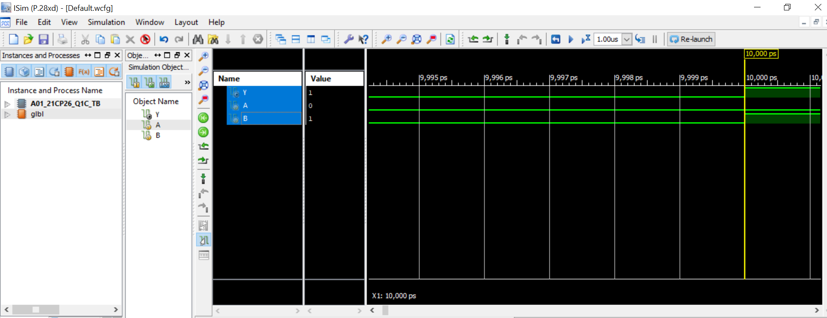

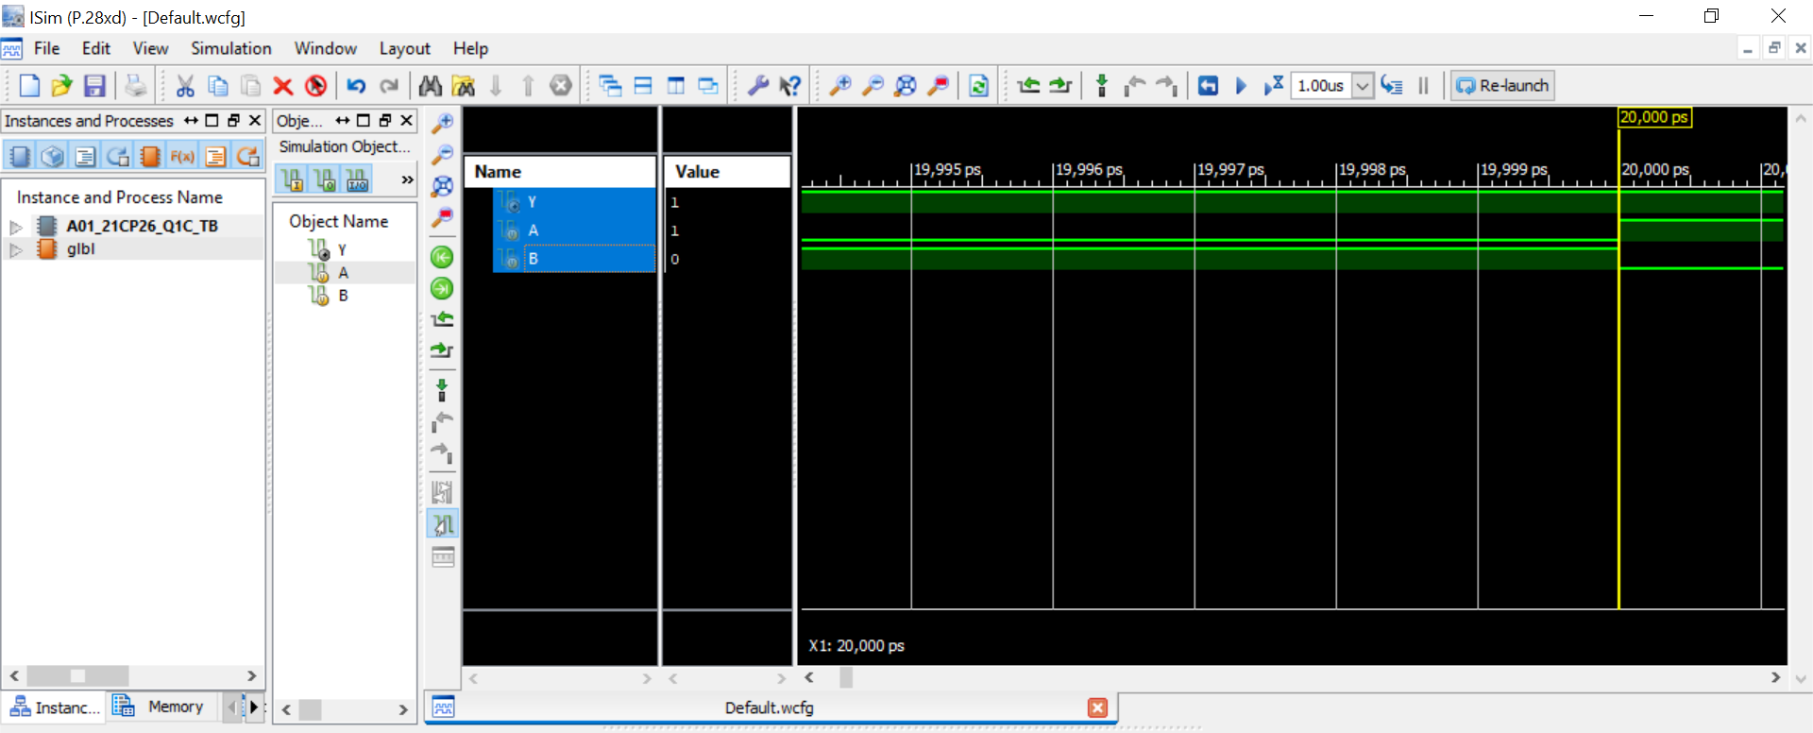

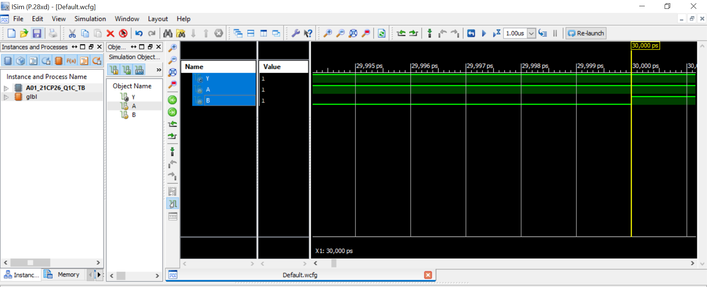

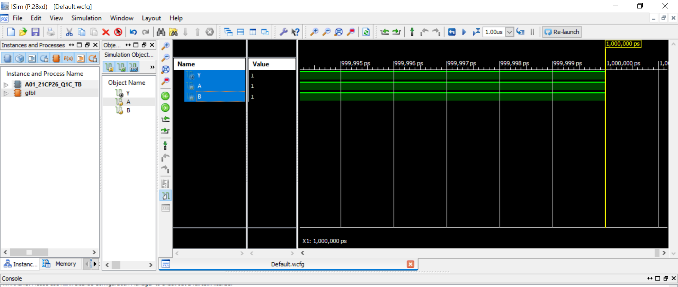

**d. 2-input xor gate**

**Truth table:**

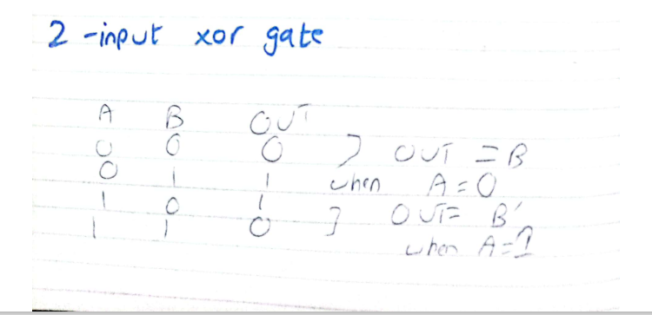

**Circuit diagram :**

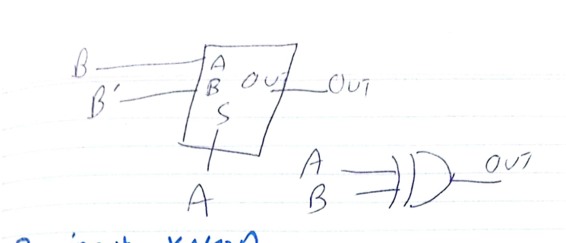

**Code:**

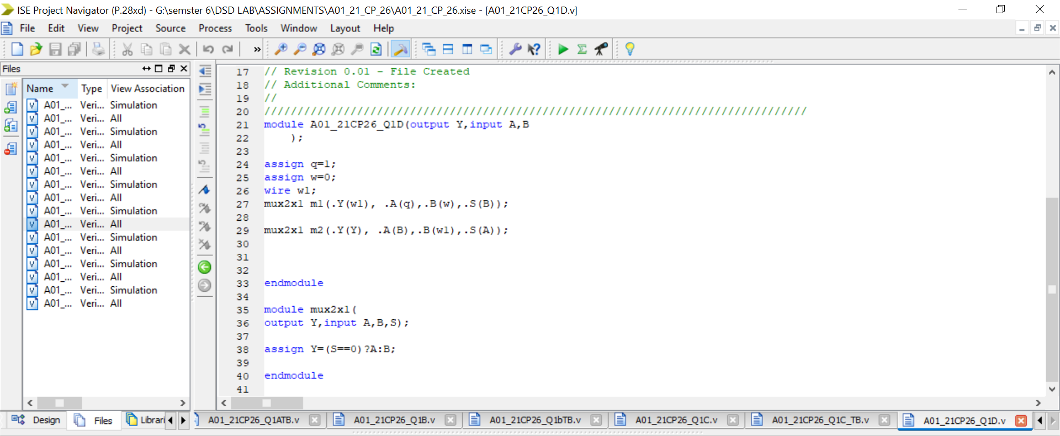

`timescale 1ns / 1ps

//////////////////////////////////////////////////////////////////////////////////

// Company:

// Engineer:

//

// Create Date: 00:20:38 02/03/2024

// Design Name:

// Module Name: A01_21CP26_Q1D

// Project Name:

// Target Devices:

// Tool versions:

// Description:

//

// Dependencies:

//

// Revision:

// Revision 0.01 - File Created

// Additional Comments:

//

//////////////////////////////////////////////////////////////////////////////////

module A01_21CP26_Q1D(output Y,input A,B

);

assign q=1;

assign w=0;

wire w1;

mux2x1 m1(.Y(w1), .A(q),.B(w),.S(B));

mux2x1 m2(.Y(Y), .A(B),.B(w1),.S(A));

endmodule

module mux2x1(

output Y,input A,B,S);

assign Y=(S==0)?A:B;

endmodule

**TestBench:**

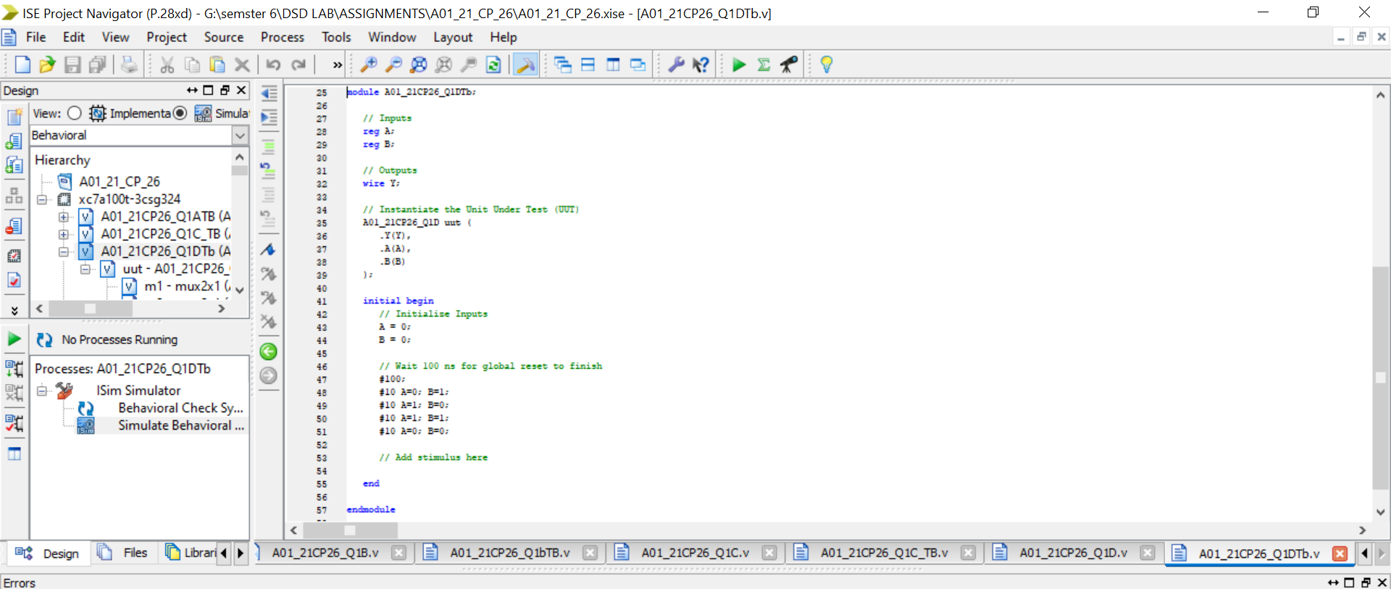

`timescale 1ns / 1ps

////////////////////////////////////////////////////////////////////////////////

// Company:

// Engineer:

//

// Create Date: 00:26:00 02/03/2024

// Design Name: A01_21CP26_Q1D

// Module Name: G:/semster 6/DSD LAB/ASSIGNMENTS/A01_21_CP_26/A01_21CP26_Q1DTb.v

// Project Name: A01_21_CP_26

// Target Device:

// Tool versions:

// Description:

//

// Verilog Test Fixture created by ISE for module: A01_21CP26_Q1D

//

// Dependencies:

//

// Revision:

// Revision 0.01 - File Created

// Additional Comments:

//

////////////////////////////////////////////////////////////////////////////////

module A01_21CP26_Q1DTb;

// Inputs

reg A;

reg B;

// Outputs

wire Y;

// Instantiate the Unit Under Test (UUT)

A01_21CP26_Q1D uut (

.Y(Y),

.A(A),

.B(B)

);

initial begin

// Initialize Inputs

A = 0;

B = 0;

// Wait 100 ns for global reset to finish

#100;

#10 A=0; B=1;

#10 A=1; B=0;

#10 A=1; B=1;

#10 A=0; B=0;

// Add stimulus here

end

endmodule

**Simulation:**

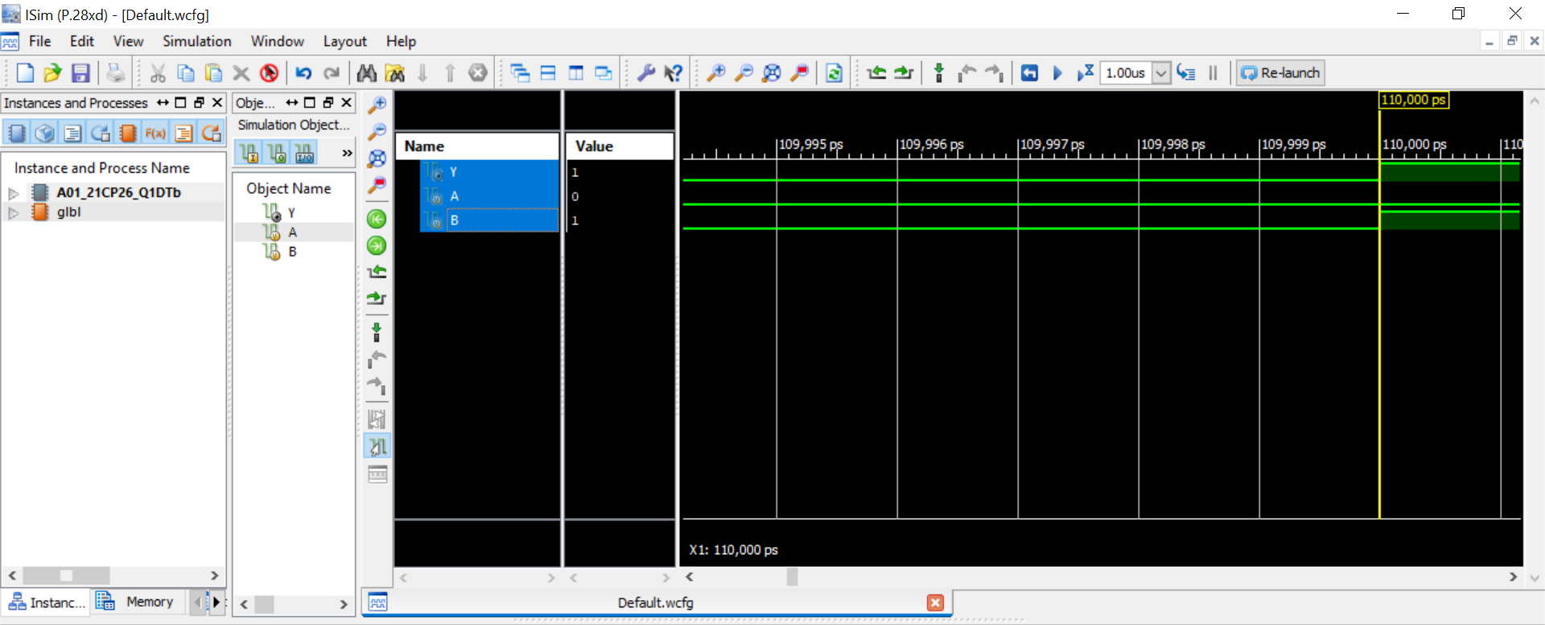

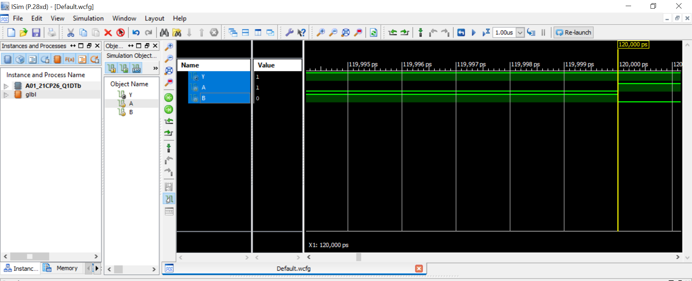

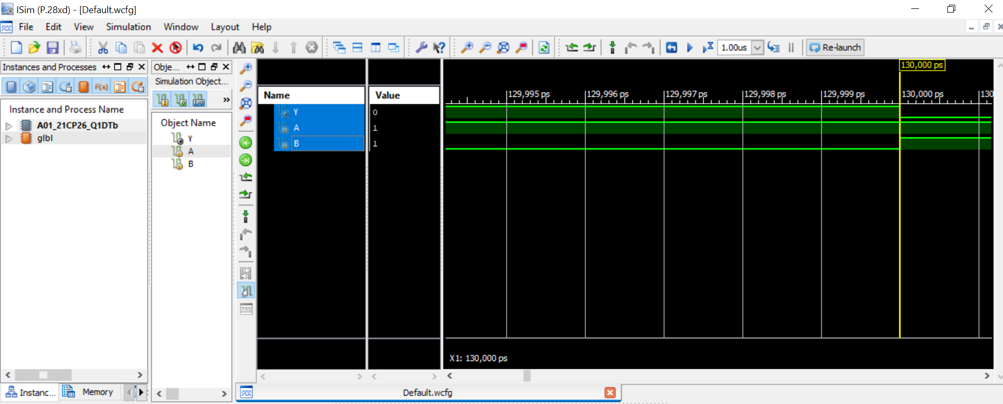

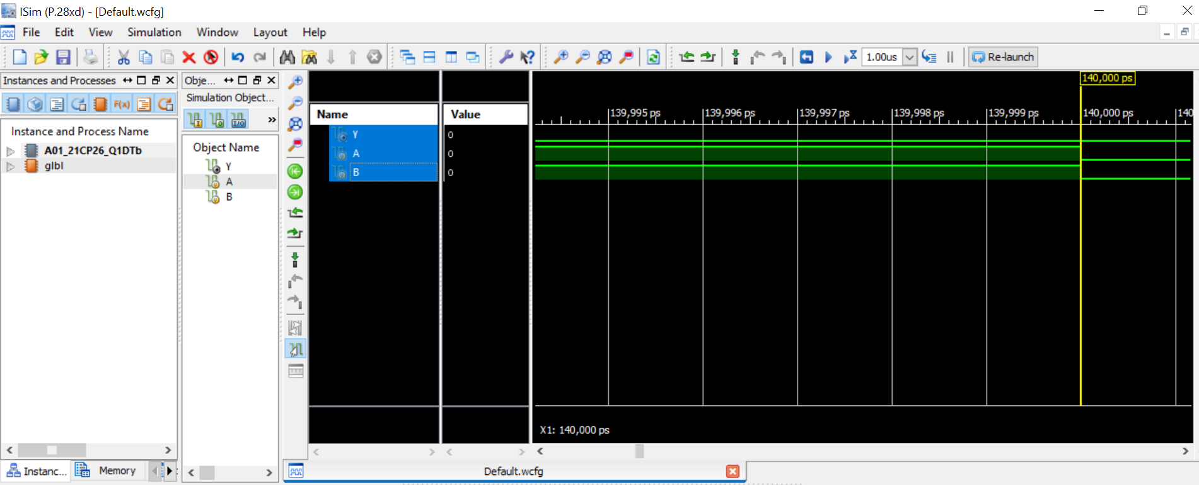

**e. 2-input xnor gate**

**Truth table:**

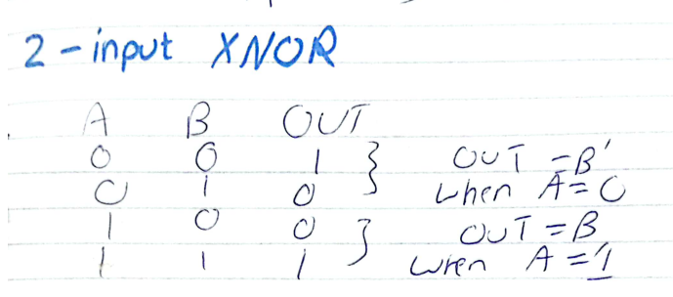

**Circuit diagram :**

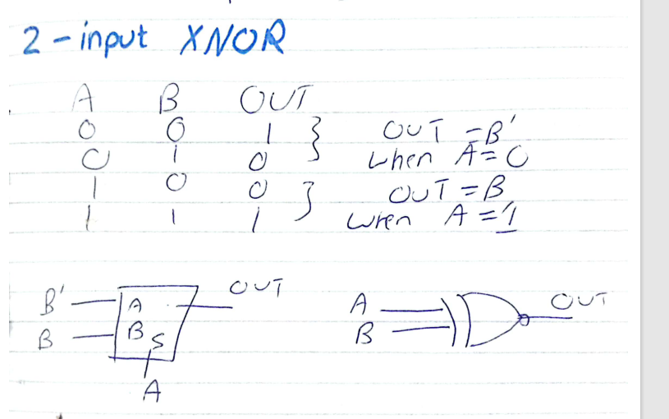

**Code:**

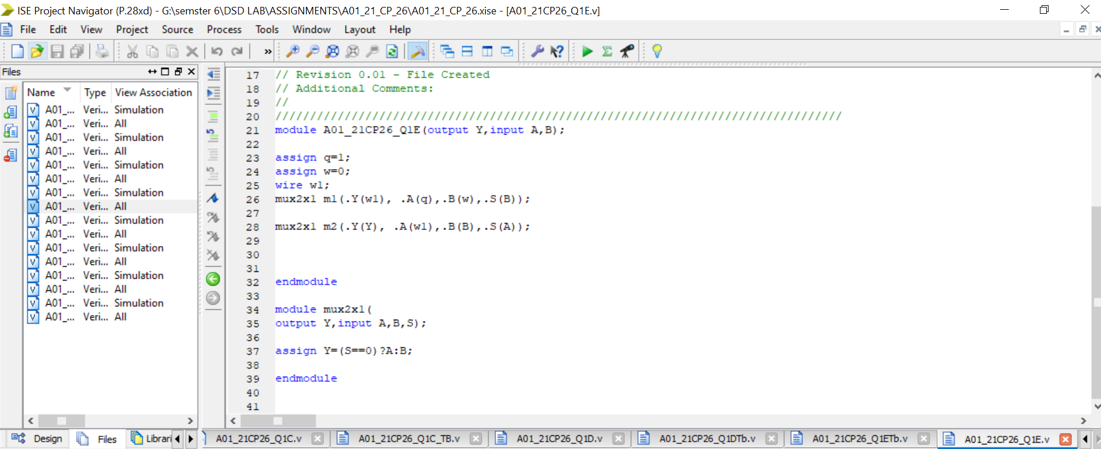

`timescale 1ns / 1ps

//////////////////////////////////////////////////////////////////////////////////

// Company:

// Engineer:

//

// Create Date: 00:32:26 02/03/2024

// Design Name:

// Module Name: A01_21CP26_Q1E

// Project Name:

// Target Devices:

// Tool versions:

// Description:

//

// Dependencies:

//

// Revision:

// Revision 0.01 - File Created

// Additional Comments:

//

//////////////////////////////////////////////////////////////////////////////////

module A01_21CP26_Q1E(output Y,input A,B);

assign q=1;

assign w=0;

wire w1;

mux2x1 m1(.Y(w1), .A(q),.B(w),.S(B));

mux2x1 m2(.Y(Y), .A(w1),.B(B),.S(A));

endmodule

module mux2x1(

output Y,input A,B,S);

assign Y=(S==0)?A:B;

endmodule

**TestBench:**

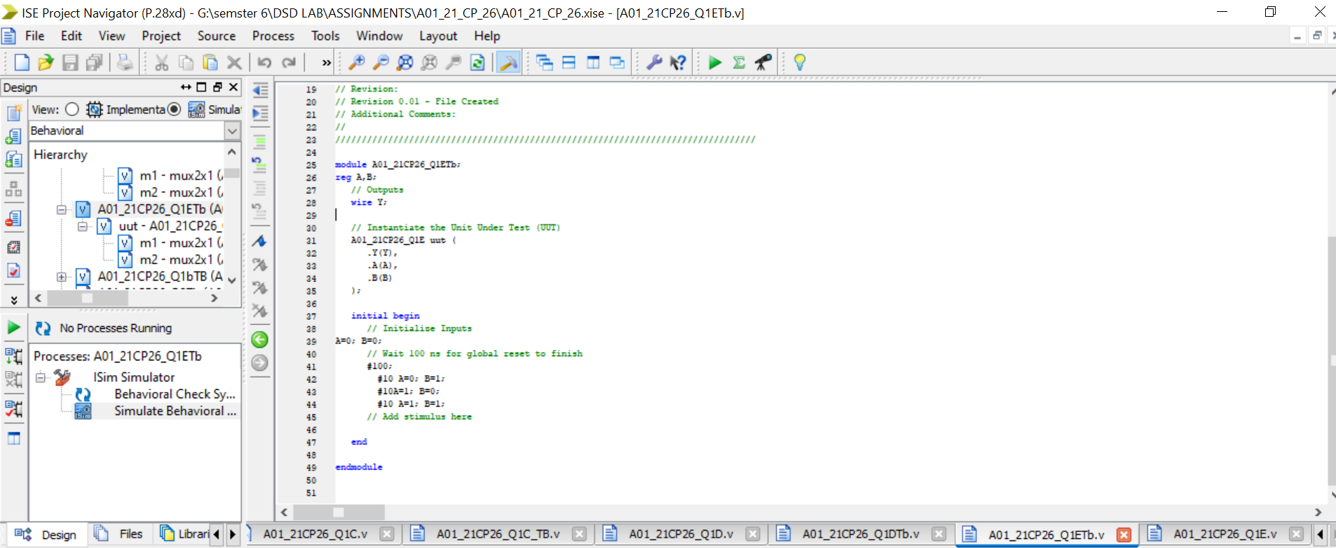

`timescale 1ns / 1ps

////////////////////////////////////////////////////////////////////////////////

// Company:

// Engineer:

//

// Create Date: 00:34:13 02/03/2024

// Design Name: A01_21CP26_Q1E

// Module Name: G:/semster 6/DSD LAB/ASSIGNMENTS/A01_21_CP_26/A01_21CP26_Q1ETb.v

// Project Name: A01_21_CP_26

// Target Device:

// Tool versions:

// Description:

//

// Verilog Test Fixture created by ISE for module: A01_21CP26_Q1E

//

// Dependencies:

//

// Revision:

// Revision 0.01 - File Created

// Additional Comments:

//

////////////////////////////////////////////////////////////////////////////////

module A01_21CP26_Q1ETb;

reg A,B;

// Outputs

wire Y;

// Instantiate the Unit Under Test (UUT)

A01_21CP26_Q1E uut (

.Y(Y),

.A(A),

.B(B)

);

initial begin

// Initialize Inputs

A=0; B=0;

// Wait 100 ns for global reset to finish

#100;

#10 A=0; B=1;

#10A=1; B=0;

#10 A=1; B=1;

// Add stimulus here

end

endmodule

**Simulation:**

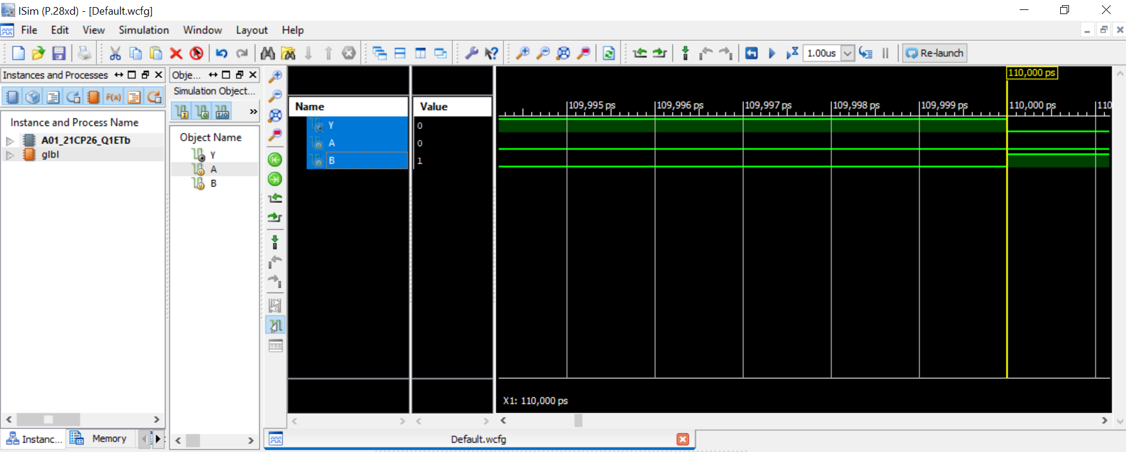

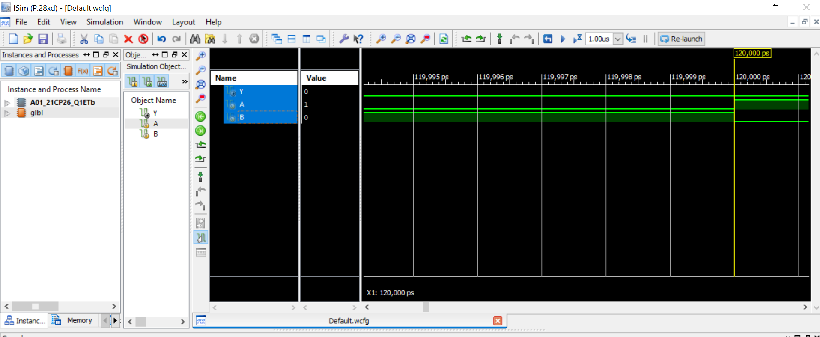

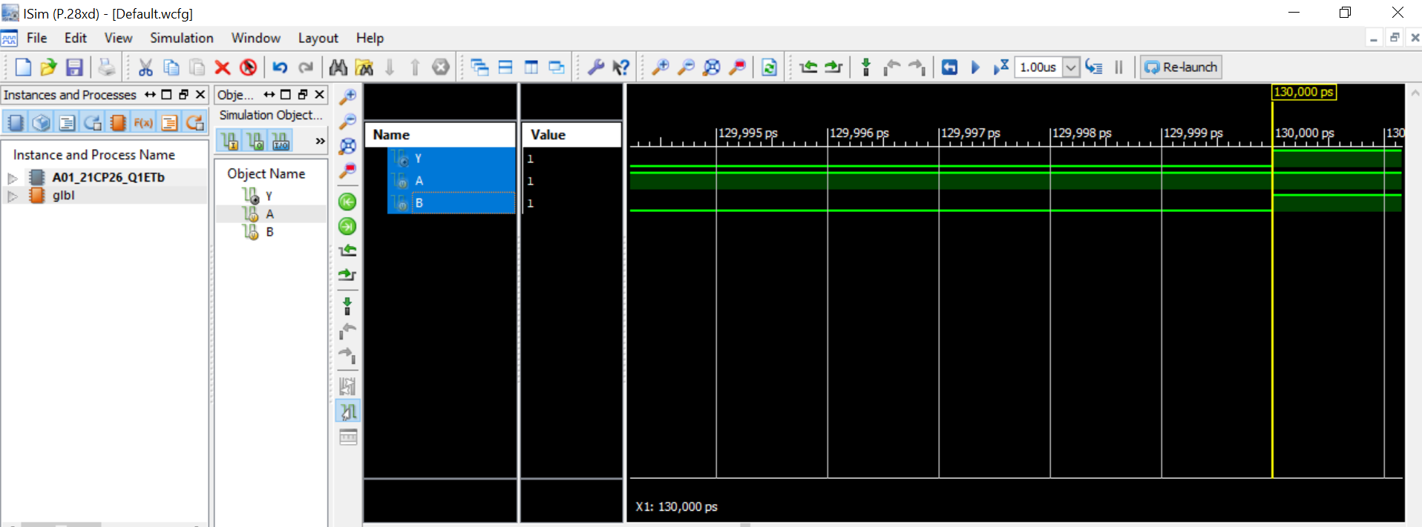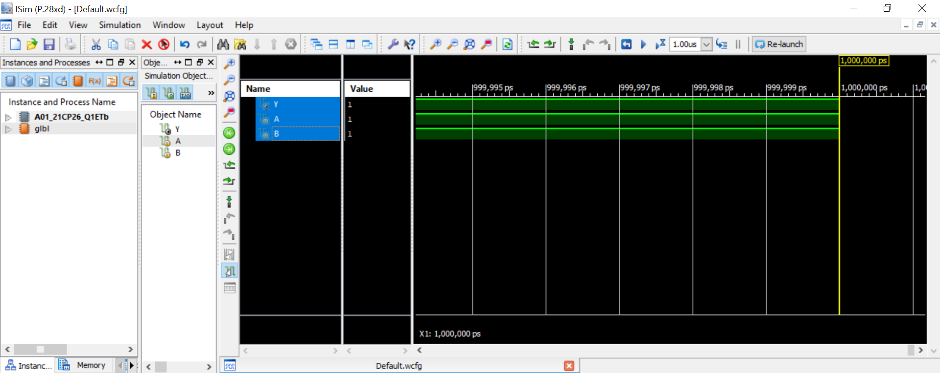

**2. Design a 16-to-1 Multiplexer using 2-to-1 Multiplexer only. (20 Marks)**

**Truth table:**

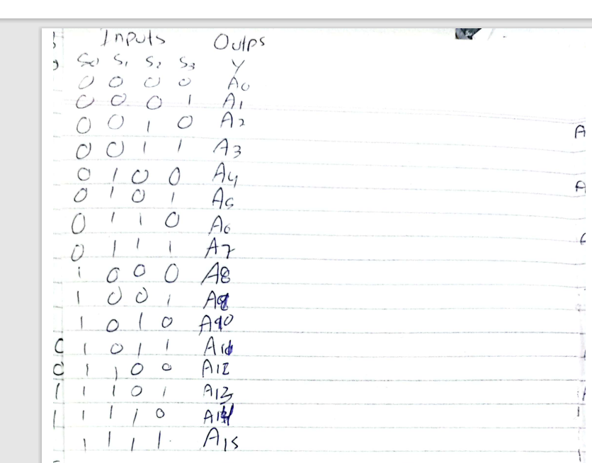

**Circuit diagram :**

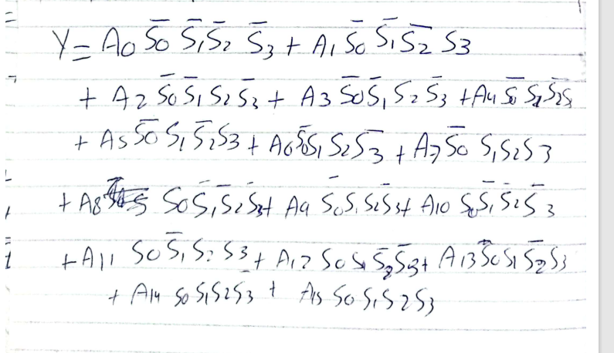

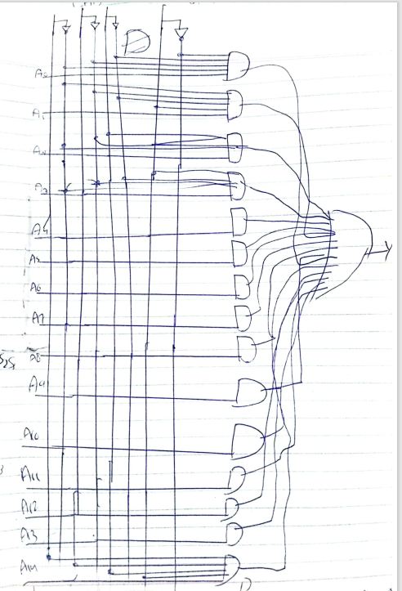

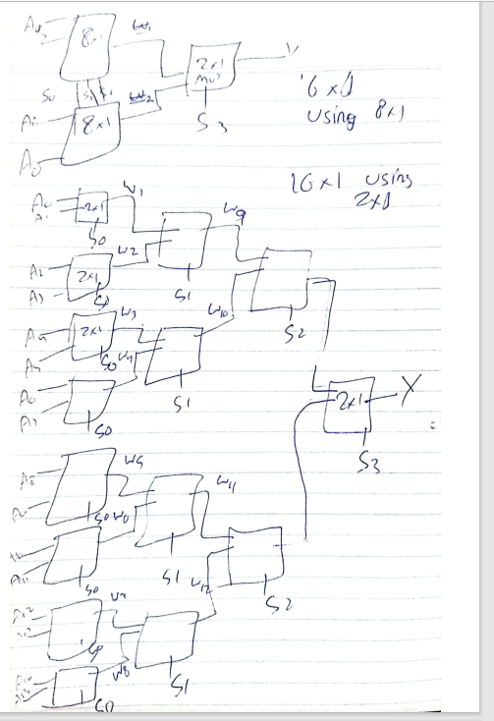

**Code:**

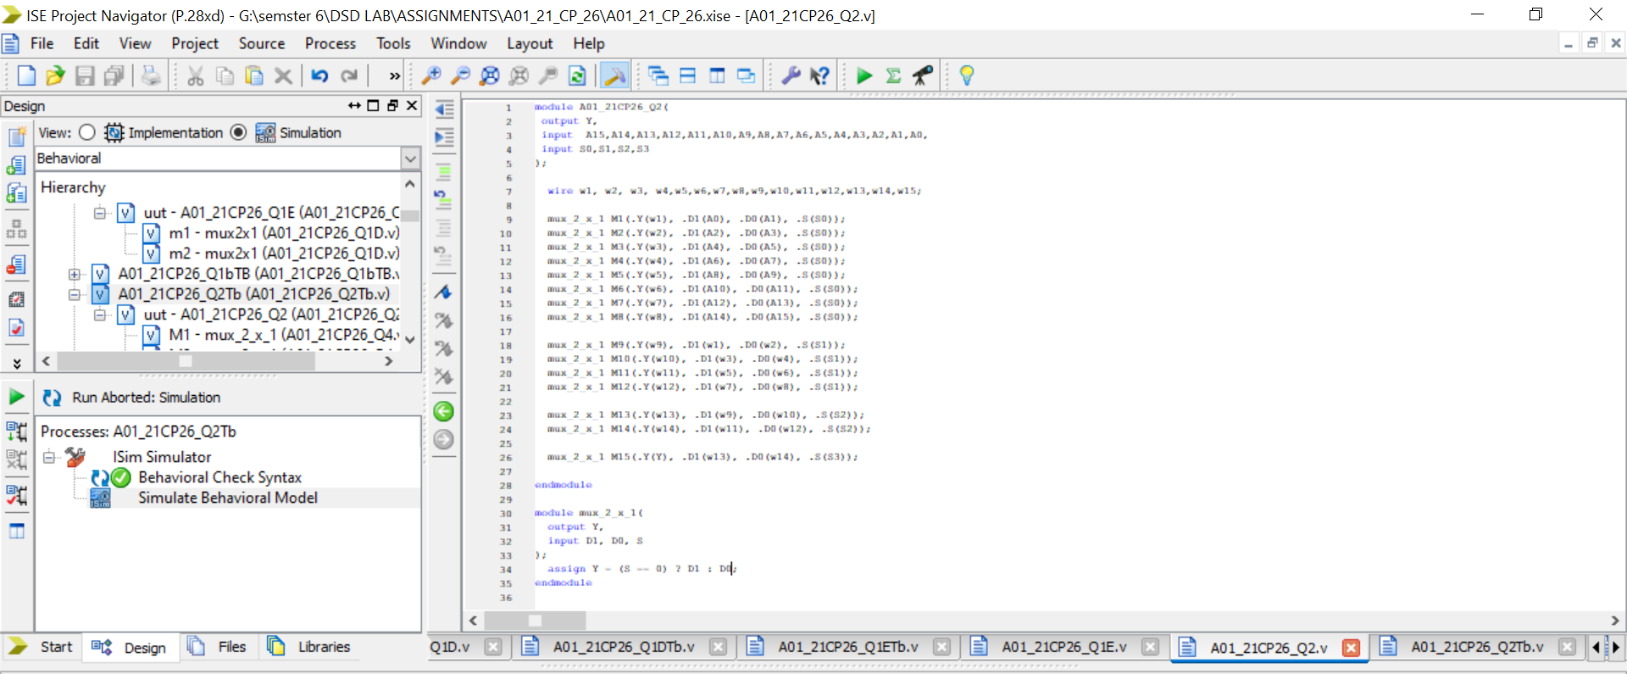

module A01_21CP26_Q2(

output Y,

input A15,A14,A13,A12,A11,A10,A9,A8,A7,A6,A5,A4,A3,A2,A1,A0,

input S0,S1,S2,S3

);

wire w1, w2, w3, w4,w5,w6,w7,w8,w9,w10,w11,w12,w13,w14,w15;

mux_2_x_1 M1(.Y(w1), .D1(A0), .D0(A1), .S(S0));

mux_2_x_1 M2(.Y(w2), .D1(A2), .D0(A3), .S(S0));

mux_2_x_1 M3(.Y(w3), .D1(A4), .D0(A5), .S(S0));

mux_2_x_1 M4(.Y(w4), .D1(A6), .D0(A7), .S(S0));

mux_2_x_1 M5(.Y(w5), .D1(A8), .D0(A9), .S(S0));

mux_2_x_1 M6(.Y(w6), .D1(A10), .D0(A11), .S(S0));

mux_2_x_1 M7(.Y(w7), .D1(A12), .D0(A13), .S(S0));

mux_2_x_1 M8(.Y(w8), .D1(A14), .D0(A15), .S(S0));

mux_2_x_1 M9(.Y(w9), .D1(w1), .D0(w2), .S(S1));

mux_2_x_1 M10(.Y(w10), .D1(w3), .D0(w4), .S(S1));

mux_2_x_1 M11(.Y(w11), .D1(w5), .D0(w6), .S(S1));

mux_2_x_1 M12(.Y(w12), .D1(w7), .D0(w8), .S(S1));

mux_2_x_1 M13(.Y(w13), .D1(w9), .D0(w10), .S(S2));

mux_2_x_1 M14(.Y(w14), .D1(w11), .D0(w12), .S(S2));

mux_2_x_1 M15(.Y(Y), .D1(w13), .D0(w14), .S(S3));

endmodule

module mux_2_x_1(

output Y,

input D1, D0, S

);

assign Y = (S == 0) ? D1 : D0;

endmodule

**TestBench:**

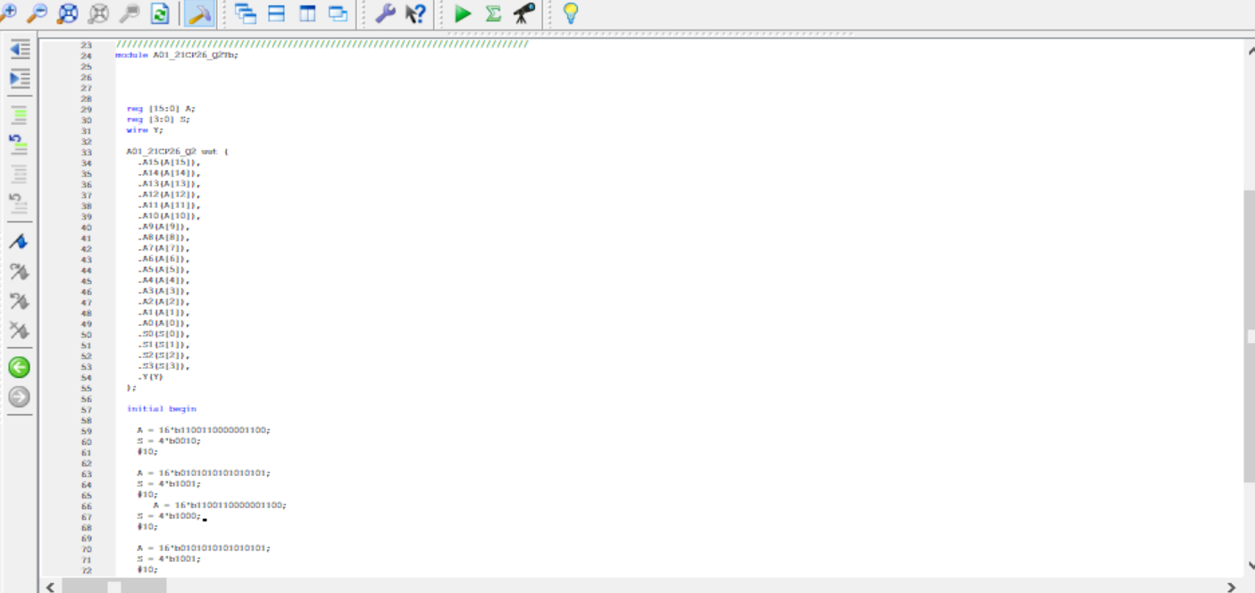

`timescale 1ns / 1ps

////////////////////////////////////////////////////////////////////////////////

// Company:

// Engineer:

//

// Create Date: 15:26:55 01/28/2024

// Design Name: A01_21CP26_Q2

// Module Name: G:/semster 6/DSD LAB/ASSIGNMENTS/A01_21_CP_26/A01_21CP26_Q2Tb.v

// Project Name: A01_21_CP_26

// Target Device:

// Tool versions:

// Description:

//

// Verilog Test Fixture created by ISE for module: A01_21CP26_Q2

//

// Dependencies:

//

// Revision:

// Revision 0.01 - File Created

// Additionl Comments

/////////////////////////////////////////////////////////////////////////////

module A01_21CP26_Q2Tb;

reg [15:0] A;

reg [3:0] S;

wire Y;

A01_21CP26_Q2 uut (

.A15(A[15]),

.A14(A[14]),

.A13(A[13]),

.A12(A[12]),

.A11(A[11]),

.A10(A[10]),

.A9(A[9]),

.A8(A[8]),

.A7(A[7]),

.A6(A[6]),

.A5(A[5]),

.A4(A[4]),

.A3(A[3]),

.A2(A[2]),

.A1(A[1]),

.A0(A[0]),

.S0(S[0]),

.S1(S[1]),

.S2(S[2]),

.S3(S[3]),

.Y(Y)

);

initial begin

A = 16'b1100110000001100;

S = 4'b0010;

#10;

A = 16'b0101010101010101;

S = 4'b1001;

#10;

A = 16'b1100110000001100;

S = 4'b1000;

#10;

A = 16'b0101010101010101;

S = 4'b1001;

#10;

A = 16'b1100110000001100;

S = 4'b0110;

#10;

A = 16'b0101010101010101;

S = 4'b1111;

#10;

end

endmodule

**Simulation:**

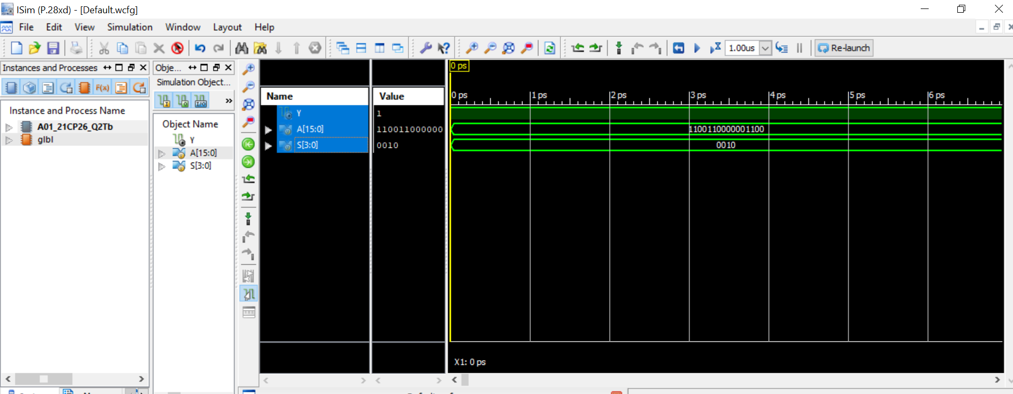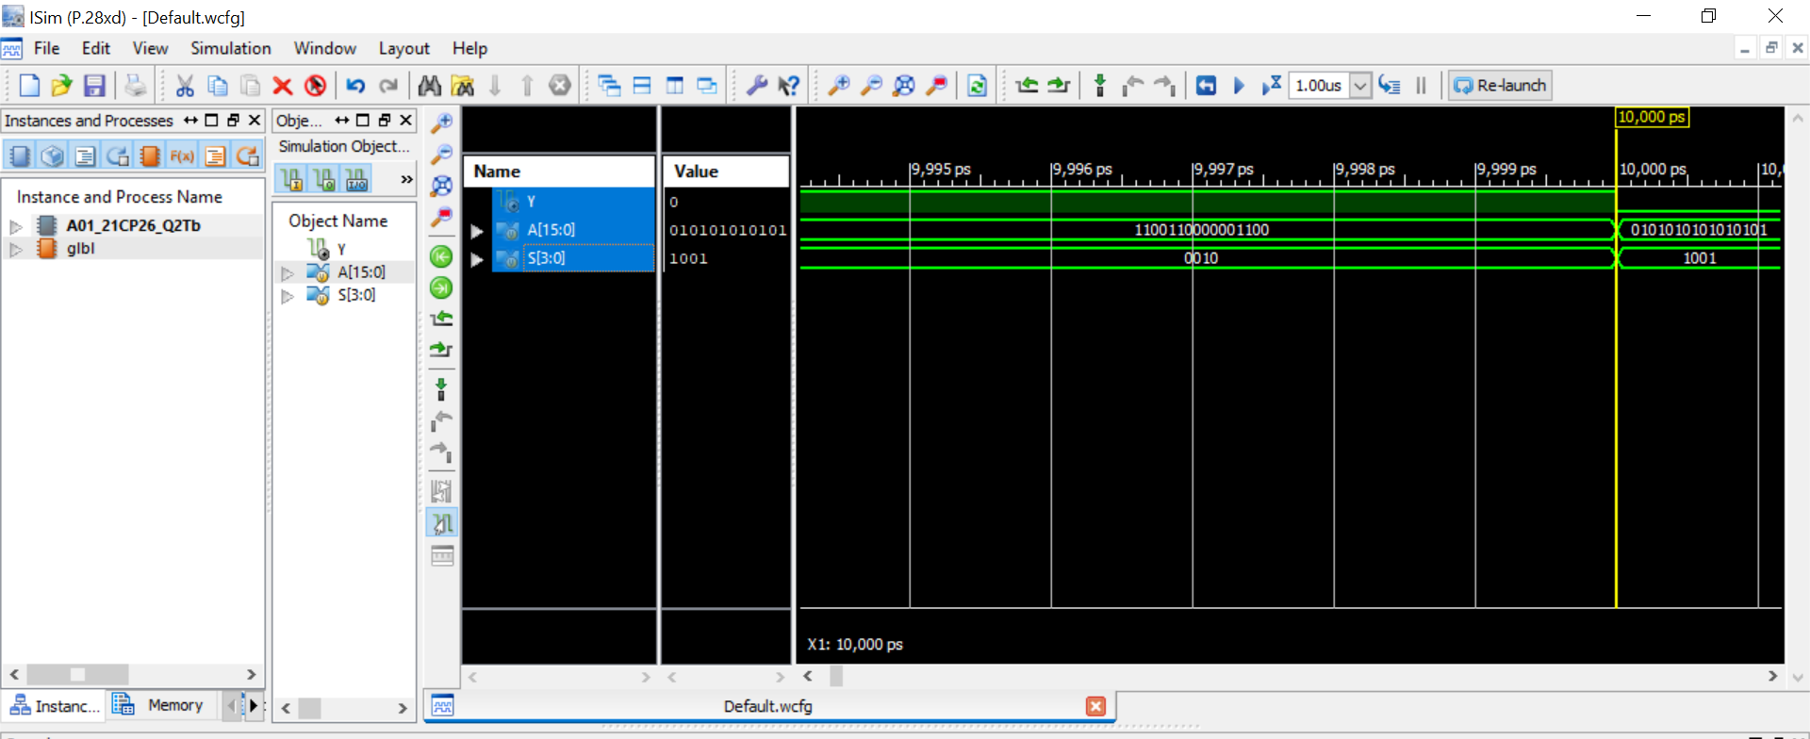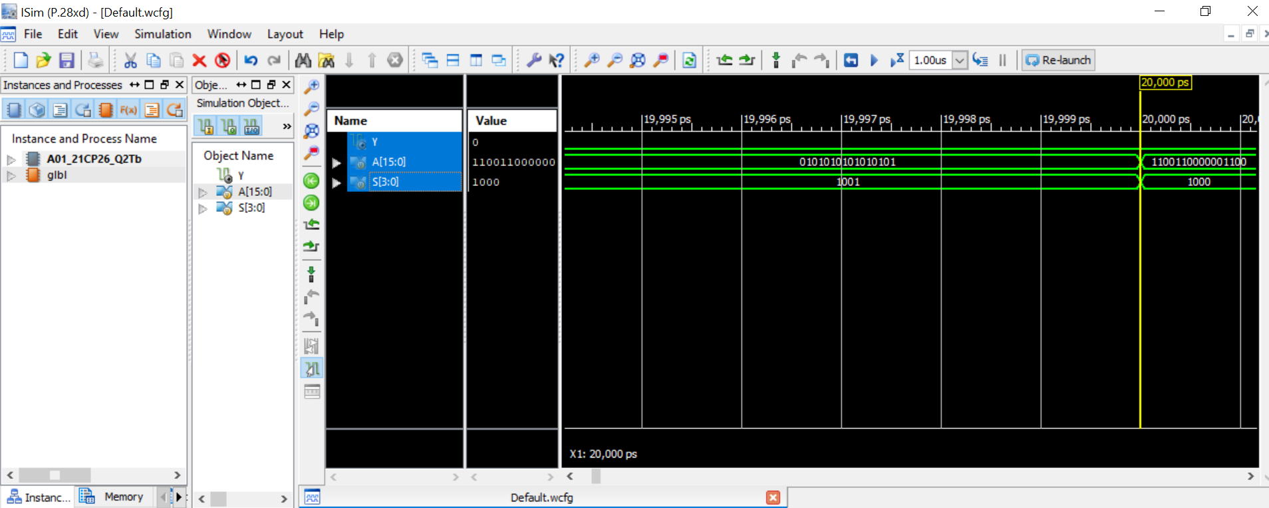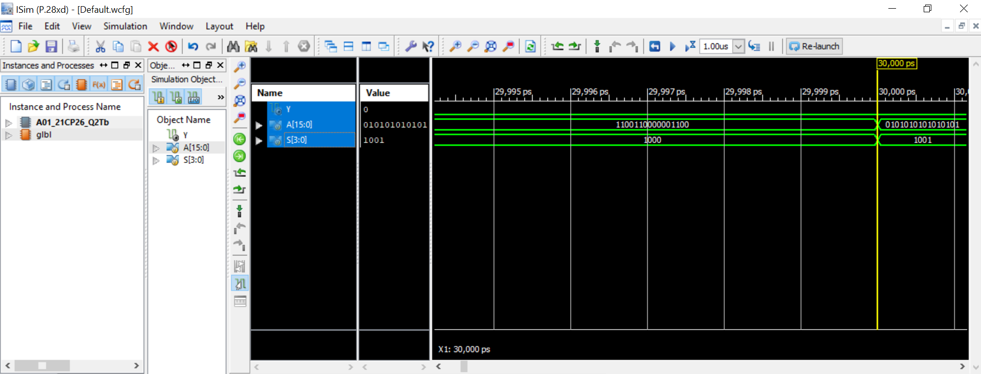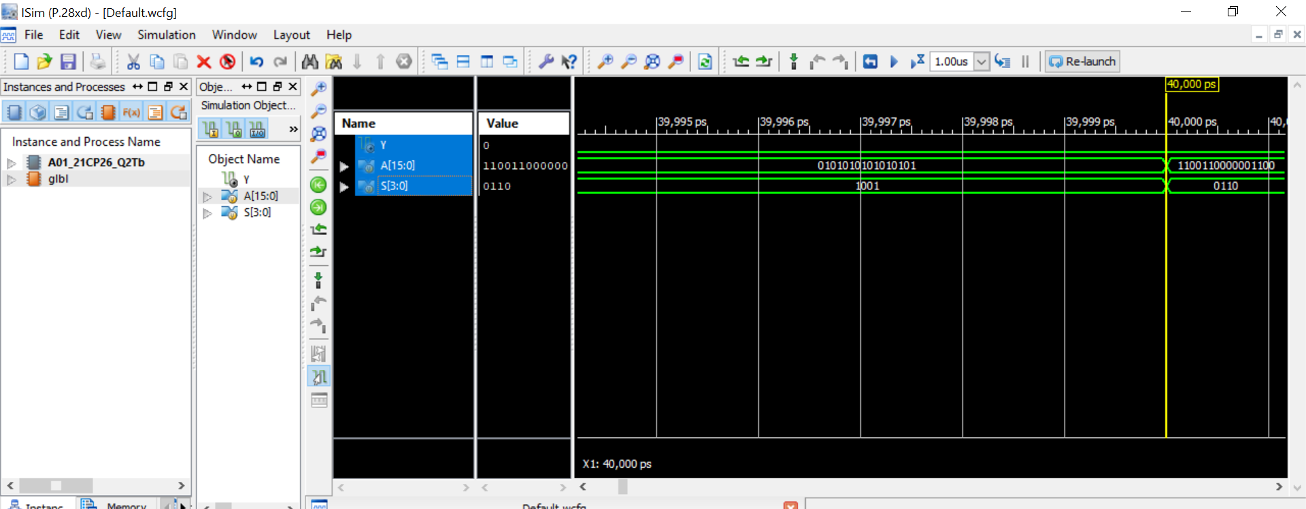

**3. Design a 3-bit comparator using multiplexer only. The input of the circuit istwo 3-bit numbers. The circuit has three binary outputs E, L, and G which become high when A==B, A B respectively. (20 Marks)**

**Truth table:**

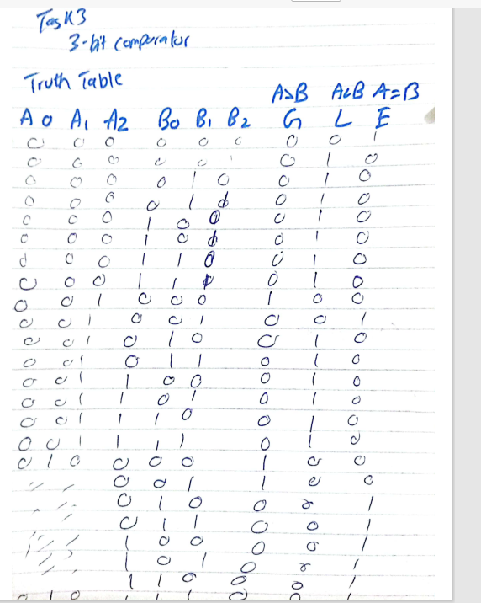

**Circuit diagram :**

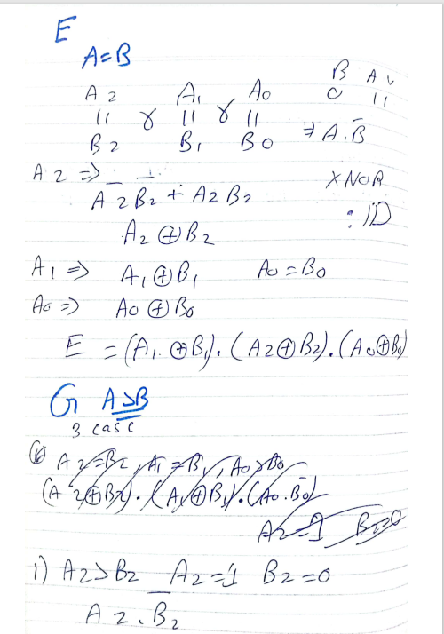

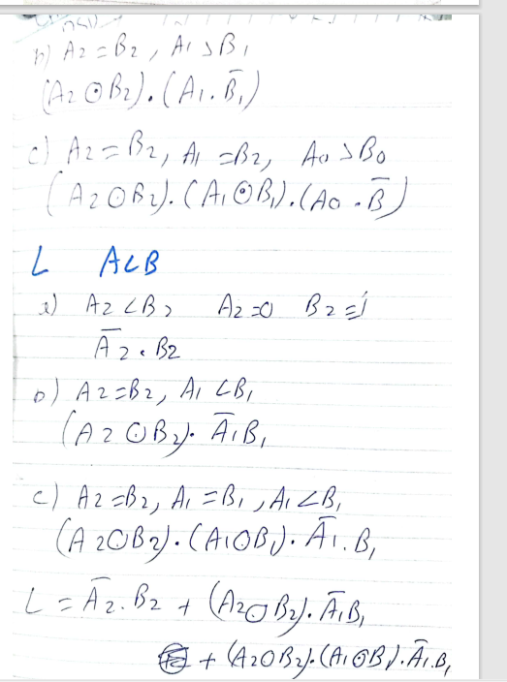

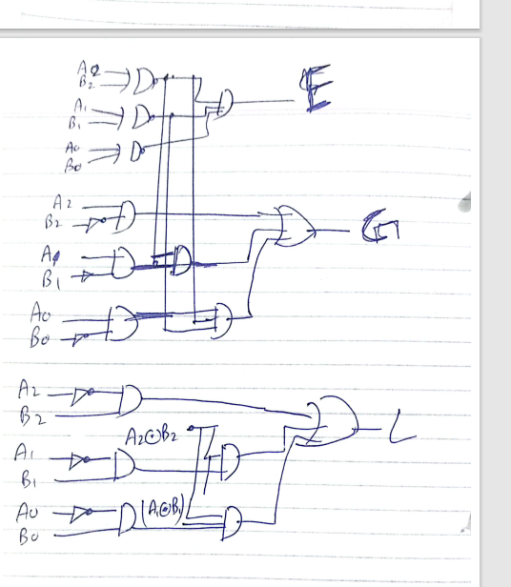

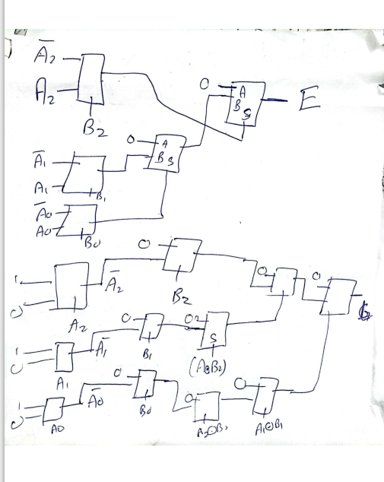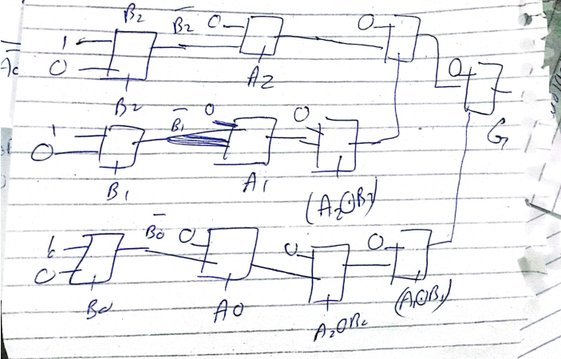

**Code:**

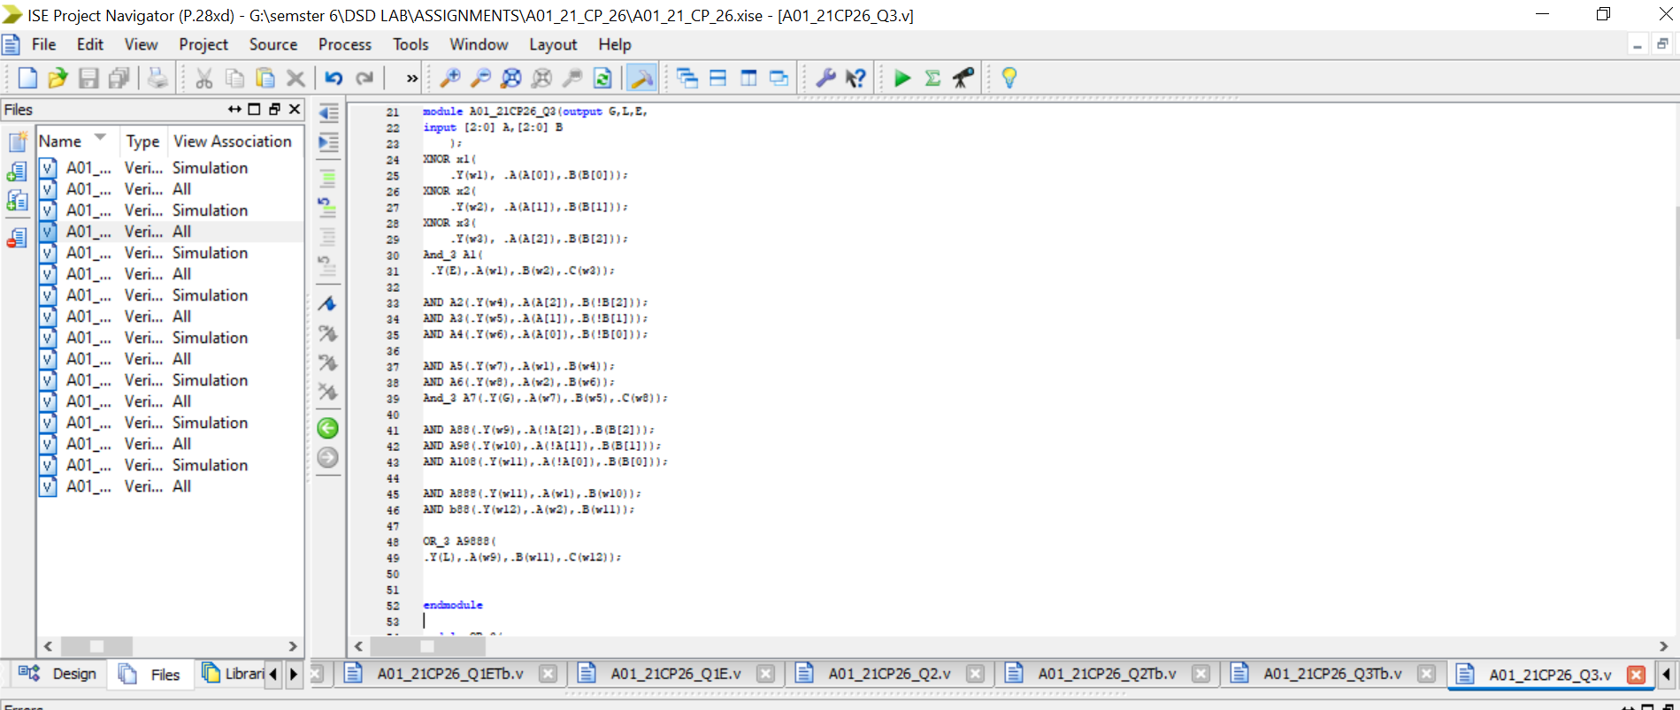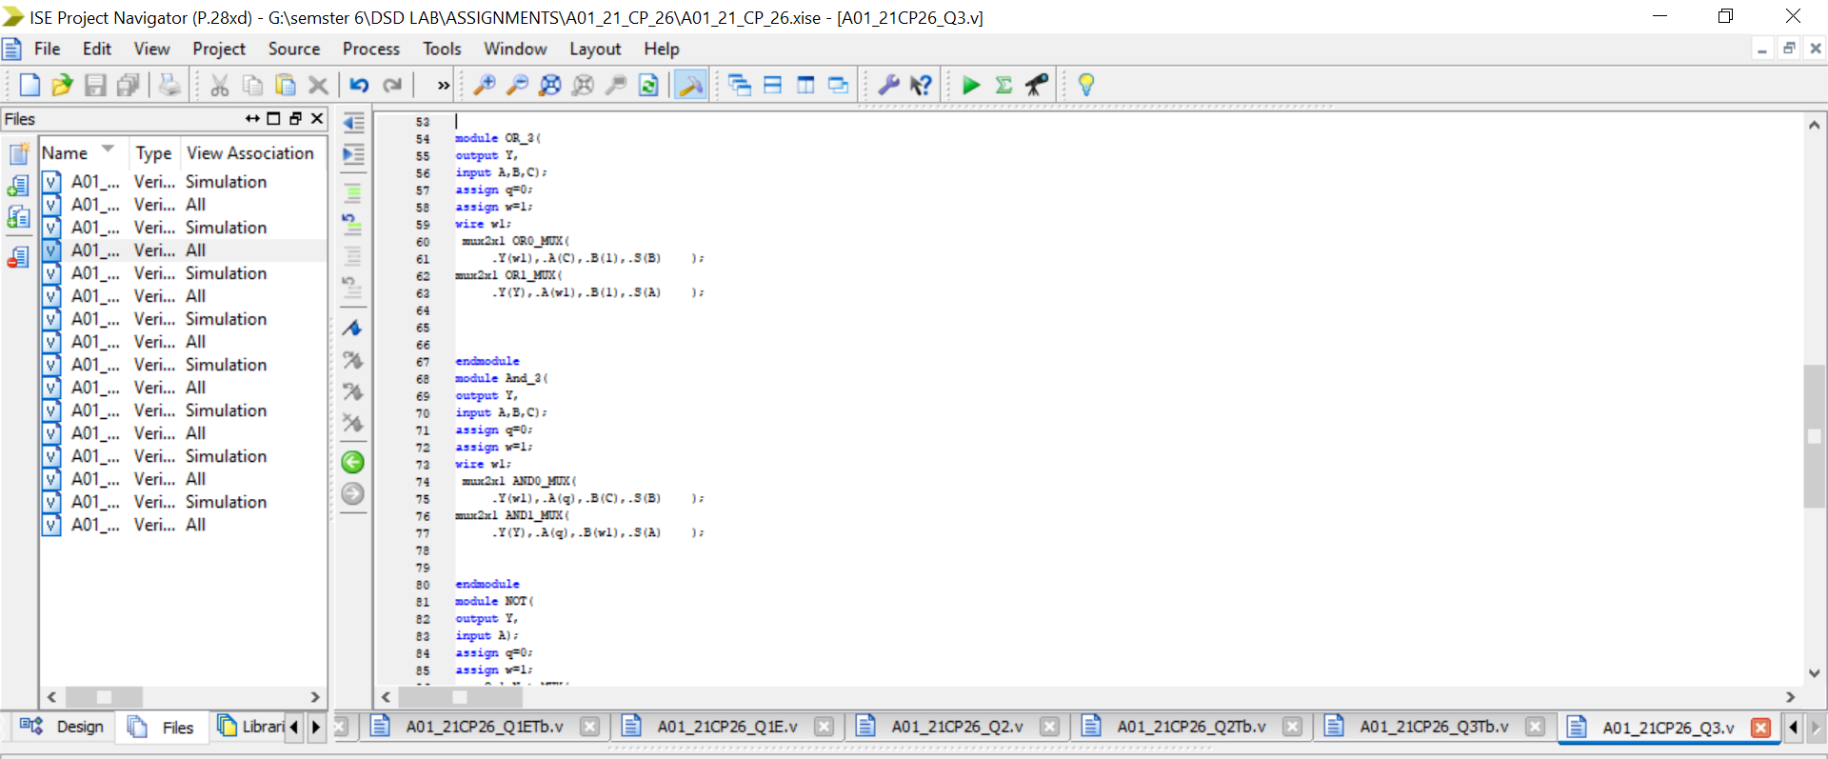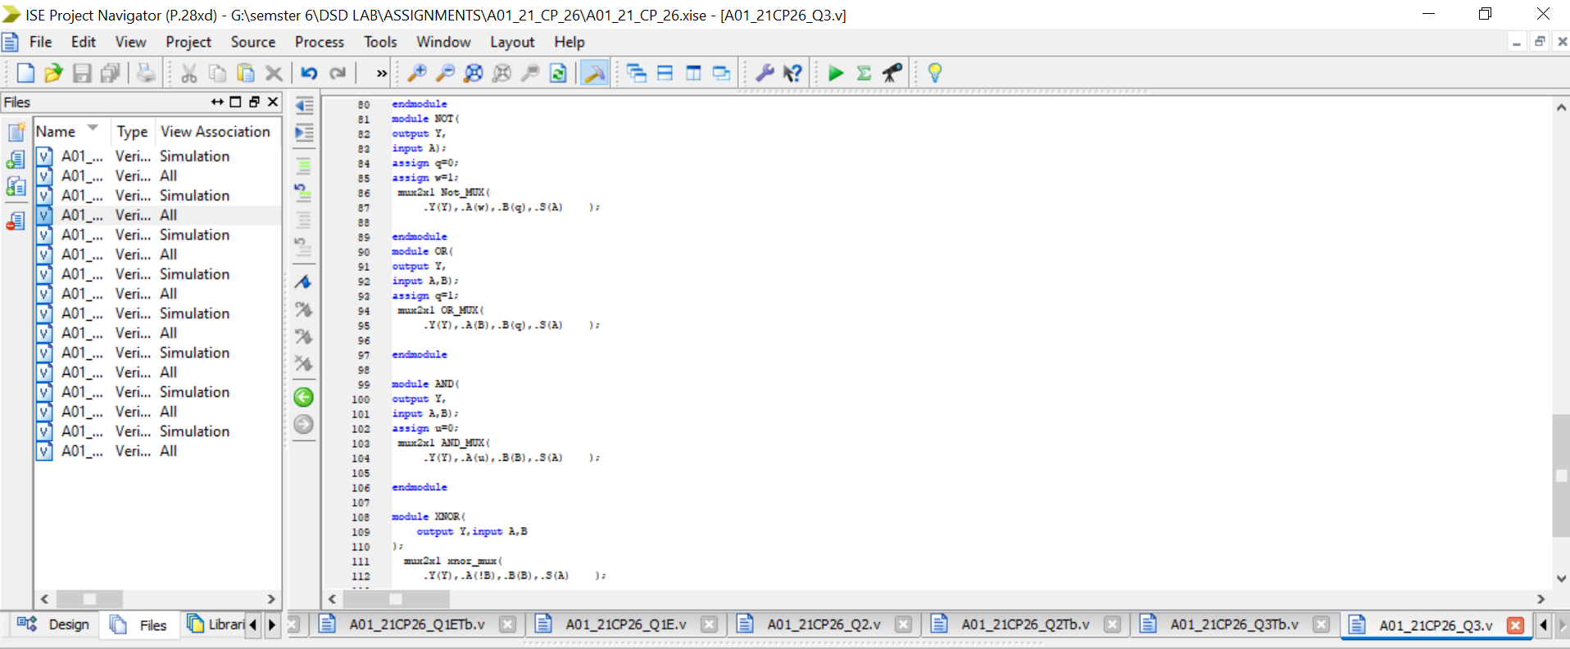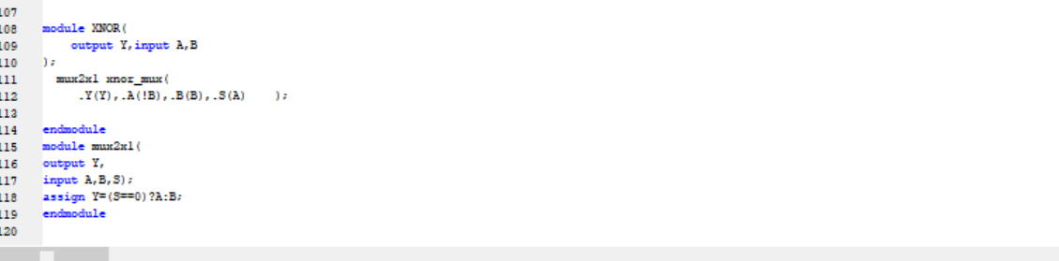

`timescale 1ns / 1ps

//////////////////////////////////////////////////////////////////////////////////

// Company:

// Engineer:

//

// Create Date: 23:19:59 02/02/2024

// Design Name:

// Module Name: A01_21CP26_Q3

// Project Name:

// Target Devices:

// Tool versions:

// Description:

//

// Dependencies:

//

// Revision:

// Revision 0.01 - File Created

// Additional Comments:

//

//////////////////////////////////////////////////////////////////////////////

module A01_21CP26_Q3(output G,L,E,

input [2:0] A,[2:0] B

);

XNOR x1(

.Y(w1), .A(A[0]),.B(B[0]));

XNOR x2(

.Y(w2), .A(A[1]),.B(B[1]));

XNOR x3(

.Y(w3), .A(A[2]),.B(B[2]));

And_3 A1(

.Y(E),.A(w1),.B(w2),.C(w3));

AND A2(.Y(w4),.A(A[2]),.B(!B[2]));

AND A3(.Y(w5),.A(A[1]),.B(!B[1]));

AND A4(.Y(w6),.A(A[0]),.B(!B[0]));

AND A5(.Y(w7),.A(w1),.B(w4));

AND A6(.Y(w8),.A(w2),.B(w6));

And_3 A7(.Y(G),.A(w7),.B(w5),.C(w8));

AND A88(.Y(w9),.A(!A[2]),.B(B[2]));

AND A98(.Y(w10),.A(!A[1]),.B(B[1]));

AND A108(.Y(w11),.A(!A[0]),.B(B[0]));

AND A888(.Y(w11),.A(w1),.B(w10));

AND b88(.Y(w12),.A(w2),.B(w11));

OR_3 A9888(

.Y(L),.A(w9),.B(w11),.C(w12));

endmodule

module OR_3(

output Y,

input A,B,C);

assign q=0;

assign w=1;

wire w1;

mux2x1 OR0_MUX(

.Y(w1),.A(C),.B(1),.S(B) );

mux2x1 OR1_MUX(

.Y(Y),.A(w1),.B(1),.S(A) );

endmodule

module And_3(

output Y,

input A,B,C);

assign q=0;

assign w=1;

wire w1;

mux2x1 AND0_MUX(

.Y(w1),.A(q),.B(C),.S(B) );

mux2x1 AND1_MUX(

.Y(Y),.A(q),.B(w1),.S(A) );

endmodule

module NOT(

output Y,

input A);

assign q=0;

assign w=1;

mux2x1 Not_MUX(

.Y(Y),.A(w),.B(q),.S(A) );

endmodule

module OR(

output Y,

input A,B);

assign q=1;

mux2x1 OR_MUX(

.Y(Y),.A(B),.B(q),.S(A) );

endmodule

module AND(

output Y,

input A,B);

assign u=0;

mux2x1 AND_MUX(

.Y(Y),.A(u),.B(B),.S(A) );

endmodule

module XNOR(

output Y,input A,B

);

mux2x1 xnor_mux(

.Y(Y),.A(!B),.B(B),.S(A) );

endmodule

module mux2x1(

output Y,

input A,B,S);

assign Y=(S==0)?A:B;

endmodule

**TestBench:**

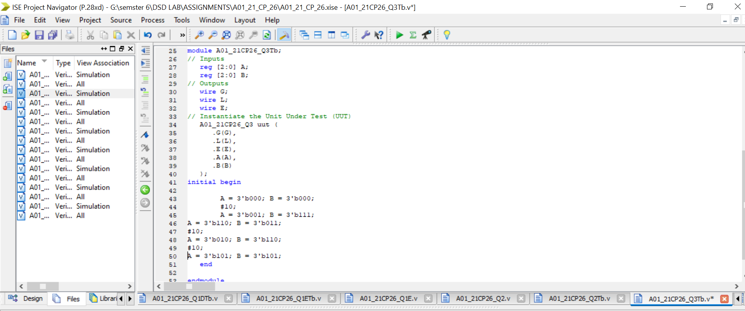

`timescale 1ns / 1ps

////////////////////////////////////////////////////////////////////////////////

// Company:

// Engineer:

//

// Create Date: 00:12:08 02/03/2024

// Design Name: A01_21CP26_Q3

// Module Name: G:/semster 6/DSD LAB/ASSIGNMENTS/A01_21_CP_26/A01_21CP26_Q3Tb.v

// Project Name: A01_21_CP_26

// Target Device:

// Tool versions:

// Description:

//

// Verilog Test Fixture created by ISE for module: A01_21CP26_Q3

//

// Dependencies:

//

// Revision:

// Revision 0.01 - File Created

// Additional Comments:

//

////////////////////////////////////////////////////////////////////////////////

module A01_21CP26_Q3Tb;

// Inputs

reg [2:0] A;

reg [2:0] B;

// Outputs

wire G;

wire L;

wire E;

// Instantiate the Unit Under Test (UUT)

A01_21CP26_Q3 uut (

.G(G),

.L(L),

.E(E),

.A(A),

.B(B)

);

initial begin

A = 3'b000; B = 3'b000;

#10;

A = 3'b001; B = 3'b111;

A = 3'b110; B = 3'b011;

#10;

A = 3'b010; B = 3'b110;

#10;

A = 3'b101; B = 3'b101;

end

endmodule

**Simulation:**

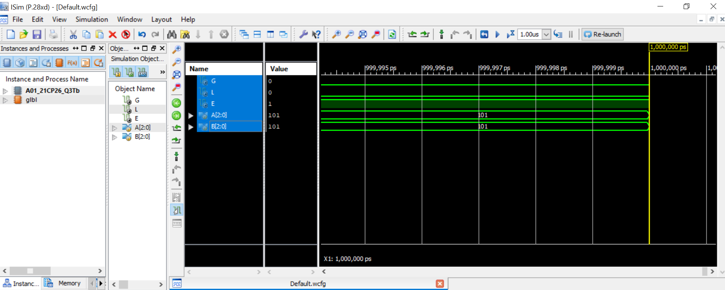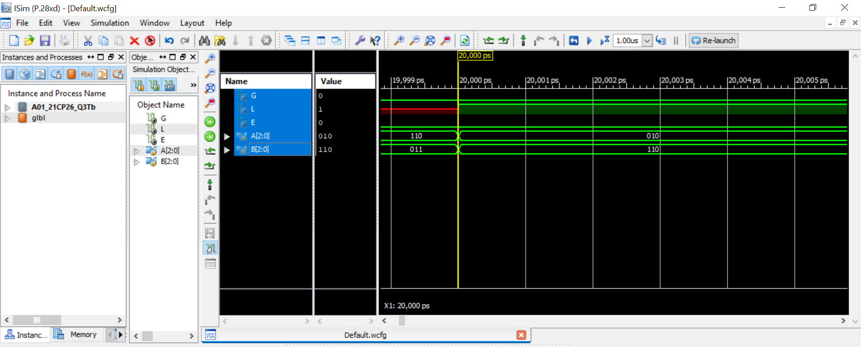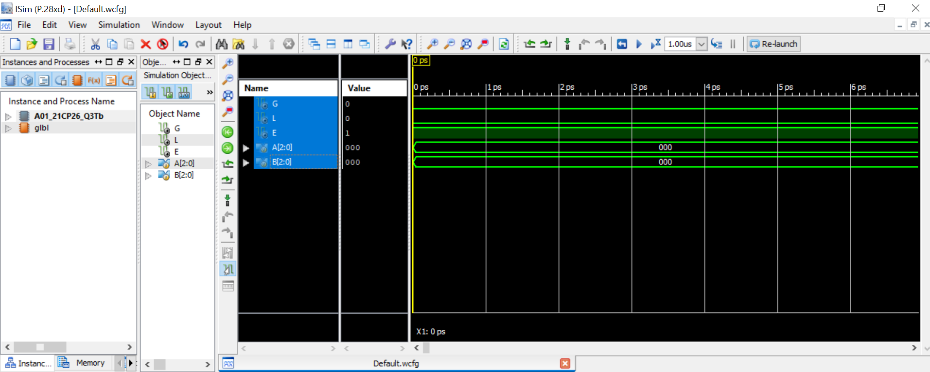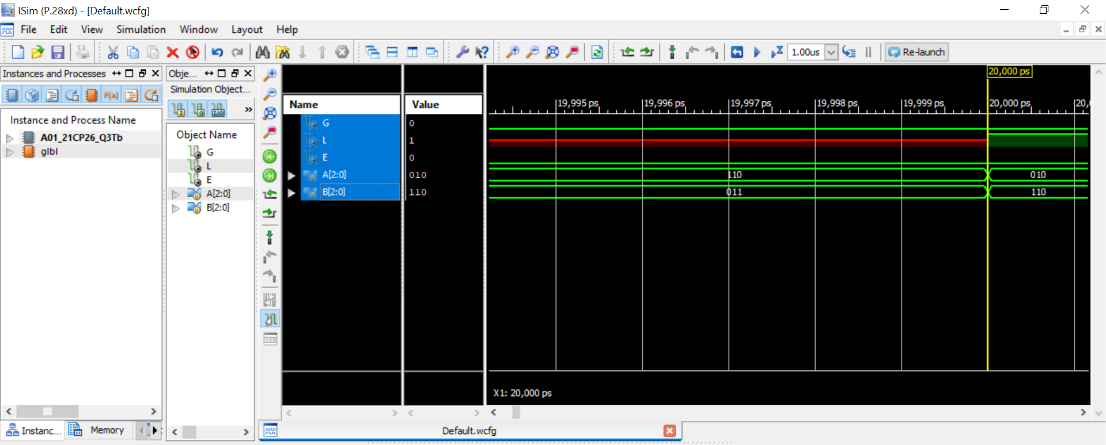

**4. Design 8 bit even parity detector using multiplexer only. The input of the circuit is a 4-bit number. The circuit provides a binary output E which becomes high for the even parity. (20 Marks)**

**Truth table:**

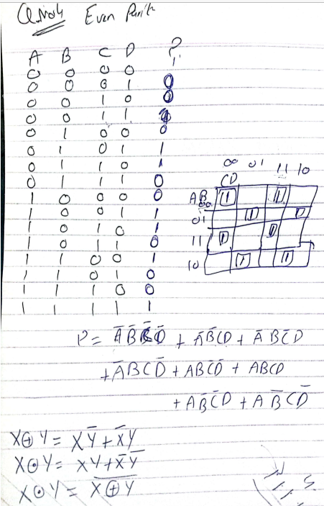

**Circuit diagram :**

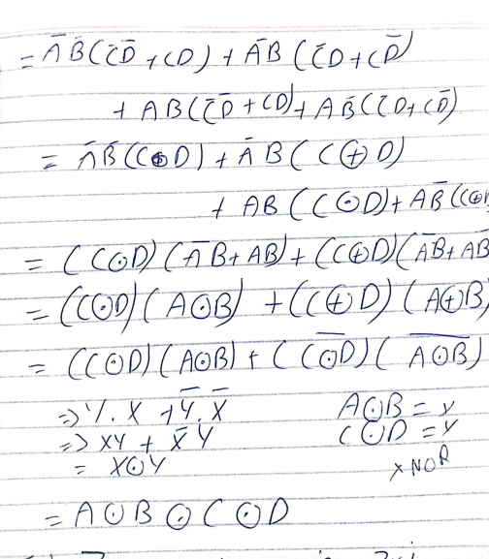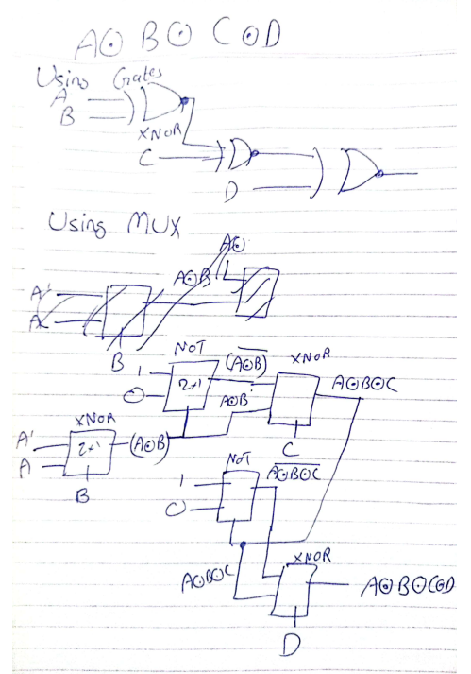

**Code:**

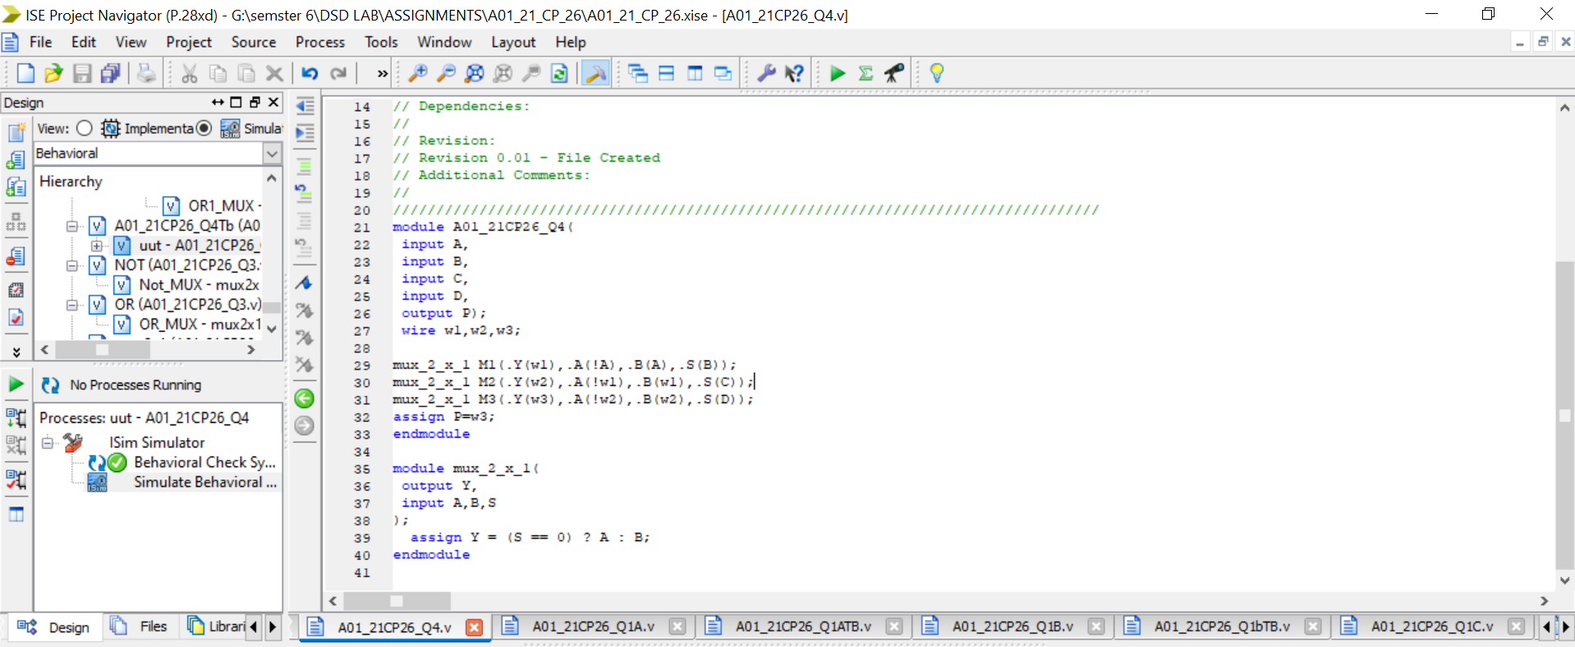

`timescale 1ns / 1ps

//////////////////////////////////////////////////////////////////////////////////

// Company:

// Engineer:

//

// Create Date: 16:30:40 01/28/2024

// Design Name:

// Module Name: A01_21CP26_Q4

// Project Name:

// Target Devices:

// Tool versions:

// Description:

//

// Dependencies:

//

// Revision:

// Revision 0.01 - File Created

// Additional Comments:

//

//////////////////////////////////////////////////////////////////////////////////

module A01_21CP26_Q4(

input A,

input B,

input C,

input D,

output P);

wire w1,w2,w3;

mux_2_x_1 M1(.Y(w1),.A(!A),.B(A),.S(B));

mux_2_x_1 M2(.Y(w2),.A(!w1),.B(w1),.S(C));

mux_2_x_1 M3(.Y(w3),.A(!w2),.B(w2),.S(D));

assign P=w3;

endmodule

module mux_2_x_1(

output Y,

input A,B,S

);

assign Y = (S == 0) ? A : B;

endmodule

**TestBench:**

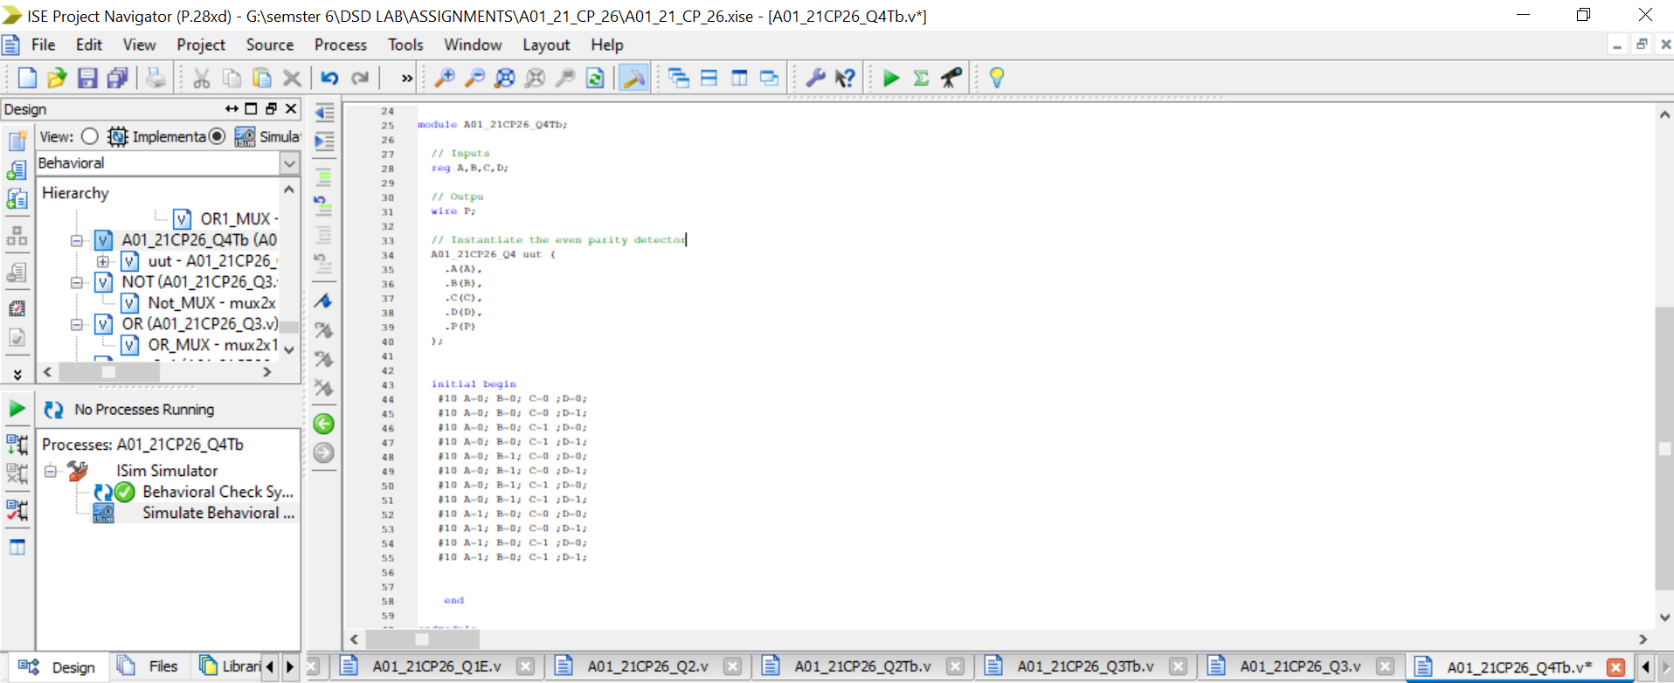

`timescale 1ns / 1ps

////////////////////////////////////////////////////////////////////////////////

// Company:

// Engineer:

//

// Create Date: 16:32:50 01/28/2024

// Design Name: A01_21CP26_Q4

// Module Name: G:/semster 6/DSD LAB/ASSIGNMENTS/A01_21_CP_26/A01_21CP26_Q4Tb.v

// Project Name: A01_21_CP_26

// Target Device:

// Tool versions:

// Description:

//

// Verilog Test Fixture created by ISE for module: A01_21CP26_Q4

//

// Dependencies:

//

// Revision:

// Revision 0.01 - File Created

// Additional Comments:

//

////////////////////////////////////////////////////////////////////////////////

module A01_21CP26_Q4Tb;

// Inputs

reg A,B,C,D;

// Outpu

wire P;

// Instantiate the even parity detector

A01_21CP26_Q4 uut (

.A(A),

.B(B),

.C(C),

.D(D),

.P(P)

);

initial begin

#10 A=0; B=0; C=0 ;D=0;

#10 A=0; B=0; C=0 ;D=1;

#10 A=0; B=0; C=1 ;D=0;

#10 A=0; B=0; C=1 ;D=1;

#10 A=0; B=1; C=0 ;D=0;

#10 A=0; B=1; C=0 ;D=1;

#10 A=0; B=1; C=1 ;D=0;

#10 A=0; B=1; C=1 ;D=1;

#10 A=1; B=0; C=0 ;D=0;

#10 A=1; B=0; C=0 ;D=1;

#10 A=1; B=0; C=1 ;D=0;

#10 A=1; B=0; C=1 ;D=1;

end

endmodule

**Simulation:**

